INTEGRATION OF MWD AND BHA DESIGN FOR VIBRATION OPTIMIZATION IN DRILLING ENVIRONMENT

A PROJECT REPORT

Submitted by

ABDUL MAJID T A (720921219001)
ELAYARAJA E (720921219016)
PRAVEEN KUMAR D N (720921219014)

In partial fulfillment for the award of the degree
of
BACHELOR OF TECHNOLGY
in
PETROLEUM ENGINEERING

JCT COLLEGE OF ENGINEERING AND TECHNOLOGY


ANNA UNIVERSITY: CHENNAI 600025
APRIL 2025

ANNA UNIVERSITY: CHENNAI 600025

BONAFIDE CERTIFICATE

Certified that this project report on “INTEGRATION OF MWD AND BHA DESIGN FOR VIBRATION OPTIMIZATION IN
DRILLING ENVIRONMENT” is the Bonafide work of ABDUL MAJID T A (720921219014), ELAYARAJA E (720921219016) PRAVEEN KUMAR DN (720921219014) for major project carried out under my guidance and supervision.

Signature of Head of the Department | Signature of the supervisor
Dr. K. RAMACHANDRAN | Mr. Samraj S (PhD IIT Delhi)
Professor | Assistant Professor
Petroleum Engineering | Petroleum Engineering
JCT College of Engineer and Technology | JCT College of Engineer and Technology
Pichanur, Coimbatore 641105. | Pichanur, Coimbatore 641105.

ACKNOWLEDGEMENT

We would like to extend my thanks to the people who so generously contributed to the work presented in this project report.
We are very thankful to our parents and family members for encouraging us and playing a crucial role in completion of the Our graduation.
We wish to express my heart felt gratitude and indebtedness to Dr. S MANOHARAN Principal of JCT College of Engineering and technology, for his help in carrying out my External project work.
I am also grateful to Dr. K. RAMACHANDRAN, Professor & Head of the Department, Department of Petroleum Engineering, JCT College of Engineering and Technology for the guidance and encouragement have been in valuable.
I would like to take this opportunity to express my deep and sincere gratitude to my supervisor, Mr. Samraj S (PhD IIT Delhi), Assistant Professor, Department of Petroleum Engineering, JCT College of engineering and technology, for his constructive guidance, inspiration and support in carrying out this project work.

TABLE OF CONTENTS

Chapter No. | Title | Page No.
 | ABSTRACT
 | LIST OF FIGURES
 | LIST OF TABLES
I | INTRODUCTION
 | 1.1 MWD
 | 1.2. POWER SYSTEMS IN MWD

S.NO TITLE PAGE NO ABSTRACT v
vi
vii
viii
- MWD 1
- 4
- DATA TRANSMISSION IN MWD 6
- MPT SYSTEM SIGNAL IMPAIRMENT 12
- INTRODUCTIONS TO SENSORS 16
- DIRECTIONAL SENSORS 23
- CORRECTIONS FOR SENSOR READING 26
- DIFFERENCE B/W MWD AND LWD 29
- DRILL STRING MAGNETIC INTERFACE 30
- WELLBORE SURVEY PARAMETERS 32
- BIT SELECTION 34
- NMDC SPACING 43
- DRILL STRING VIBRATION 49
- LOST CIRCULATION TOOL 56
- BHA DESIGN FOR VIBRATION OPTIMIZATION 61
- CONCLUSIONS 70
- REFERENCES 72

ABSTRACT
Drilling is an integral operation that needs to be carried out for the production of hydrocarbon. However, the operation is costly and requires a lot of time. Apart from the normal vertical drilling, we have the directional drilling. The cost incurred for directional drilling is even higher than the normal drilling. During drilling, it is very important to predict the drilling trajectory to identify the borehole stability and identify possible well bore problems like sanding, swelling, caving, deviation, collapse pressure. So, an optimized drilling needs to be done. This would reduce the cost, time and increase the profit. It has been found out that incorporation of MWD can help to optimize drilling operation. The data obtained using the sensors present in an MWD tool is a real time data and can be used instantaneously to predict the well bore environment.

NUMBER TITLE PAGE NO
LIST OF FIGURES

1.1 | Overview of Measurement While Drilling System | 2
3.1 | Special Drill pipe with cable | 7
3.2 | Mud Pulse Transmission overview | 9
3.2 | Electromagnetic Transmission | 10
5.1 | Draw work sensors | 18
5.2 | Hook- Load Sensors | 19
5.3 | Standpipe Pressure Sensors | 19
5.4 | Pump Stroke Sensors | 20
6.1 | Arrangement of accelerometers & magnetometers | 23
6.2 | Accelerometers | 24
6.3 (a) | Magnetometer with 2 set of wire coil | 25
6.3 (b) | Magnetometer with 2 set of wire coil | 25
7.1 | Magnetic Declination | 26
7.2 | Grid Convergence | 27
7.3 | Applying Declination & Grid Convergence | 27
7.4 | BHA Sagging | 28
8.1. | Drill String Magnetic Interference | 30
8.2 | Hole Direction | 31
11.1 | IADC dull grading categories | 37
11.2 | Tooth height measurement | 37
11.3 | Cutter wear convention (zero is no wear) | 38
11.4 | Inner/outer body designation for PDC | 38
11.5 | Measuring out of gauge | 41
12.1 | NMDC Length Selection Charts | 45

  - Torsional vibrations 51
  - Lateral vibrations 51
  - Effects of Lost-circulation on MWD 56
  - Suggestion to vibration mitigation workflow 59
  - Axial vibration 51
  - Different measurement approaches 60
  - Edge Modification 65
  - Anti-Stick-slip Technology 68

LIST OF TABLES
  - Comparison of Various modes of data transmission 11
  - Vibration mitigation 52
  - Baker Hughes severity for Lateral vibration 60
  - Baker Hughes severity for Axial vibration 61
  - Halliburton severity for Axial & Lateral vibration 61

CHAPTER-I
INTRODUCTION

Drilling operations are an integral operation without which the hydrocarbon cannot be brought on the Earth’s surface. This is done with the help of bottom hole assembly. At the end of the assembly there is a bit attached which helps to cut the rock inside the pressure [1]. This is aided with the help of the drilling mud which helps to maintain an overbalanced pressure against the formation pressure. The drilling occurs generally in the vertical directions. However, in case of complex regions, or drilling at very deep sea it becomes very difficult to drill a vertical well [2]. At that point the importance of horizontal and directional well comes into pressure. A directional well can be divided into three types on the basis of its shape like the S -well trajectory, J trajectory and Build and Hold trajectory [3].
With advancement in the drilling techniques, the system of logging in these directional well got difficult due to the change in angle of inclination. So, tools like MWD, LWD and PWD came in the industry. An MWD tool can give the real time data of azimuth, inclination and tool face during the drilling process. The LWD tool helps to figure out the formation properties like porosity, permeability, saturation and pay zone. The PWD tool can determine the real time pressure while the drilling is done. All these data help to forecast drilling trajectory and also modify the weight of the drilling mud as we drill in greater depths.
Measurement While Drilling (MWD) is a system developed to perform drilling related measurements downhole and transmit information to the surface while drilling a well. The MWD tool came into application in early 1970’s. Before the introduction of MWD, all survey data were obtained by stopping the drilling process for wireline logging. For wireline logging, we had to stop the drilling process, put the drill pipe on slip, break out Kelly, lower the wireline tool, retrieve the tool, read the survey and plan the further action. This used to increase the non -productive time (NPT).
  - MWD
MWD is the process by which certain information is measured near the bit and transmitted to surface without interrupting normal drilling operations. It is a combination of surface and downhole sensors. The sensors are installed in a special downhole tool made up as an integral part of the bottomhole assembly. Within the downhole tool there is also a transmitter to send the signals to surface via some kind of telemetry channel. The most common type of telemetry channel currently in use is the mud column inside the drill string. The signals are detected on surface, decoded and processed to provide the required information in a convenient and usable format. The great advantage of MWD is that it allows the driller and the geologist to effectively see what is happening downhole in real time. It therefore improves the decision-making process, since there is a delay of only a few minutes between measuring the parameters downhole and receiving the data on surface. MWD is used to measure 5 important drilling parameters. They include i. Inclination ii. Azimuth iii. Vibration iv. Pressure v. Temperature.

Advantages

The main advantages of MWD are listed below

    - It has rugged and reliable sensors that could measure the required data at or near the bit under dynamic drilling conditions.
    - It is a simple but effective method of transmitting the information to surface.
    - It can be easily installed and operated on any rig without causing too much disruption to normal drilling practices.
    - It is cost-effective and provides real benefits to the operator.
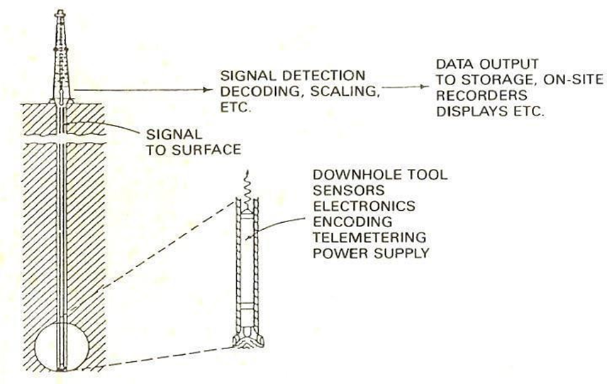
Figure: 1.1. Overview of Measurement While Drilling System

They include
- Inclination
- Azimuth
- Vibration
- Pressure
Temperature. Applications of MWD

The different types of information provided by the MWD are:

Directional Information

MWD tools are generally capable of taking directional surveys in real time. The tool uses accelerometers and magnetometers to measure the inclination and azimuth of the wellbore at that location and they then transmit the information to the surface. With a series of surveys, measurements of inclination, azimuth and tool face at appropriate intervals, the location of the wellbore can be located. MWD tools also generally provide tool face measurements to aid in directional drilling using downhole mud motors with bent subs or bent housings.

Drilling mechanics information

MWD tools can also provide information about the conditions at the drill bit. This may include:
- Rotational speed of the drill string
- Smoothness of that rotation
- Type and severity of any vibration downhole
- Downhole temperature
- Torque and weight on bit, measured near the drill bit
- Mud flow volume

Use of this information can allow the operator to drill the well more efficiently, and to ensure that the MWD tool and any other downhole tools, such as a mud motor, rotary steerable systems, and LWD tools, are operated within their technical specifications to prevent tool failure. This information is also valuable to geologists responsible for the well information about the formation which is being drilled.

Power systems in MWD

Power systems in MWD generally may be classified as one of two types: battery or turbine. Both types of power systems have inherent advantages and liabilities. In many MWD systems, a combination of these two types of power systems is used to provide power to the MWD tool so power will not be interrupted during intermittent drilling-fluid flow conditions. Batteries can provide this power independent of drilling-fluid circulation, and they are necessary if logging will occur during tripping in or out of the hole.

Battery system

Lithium batteries are commonly used in MWD systems because of their excellent combination of high-energy density and superior performance at MWD service temperatures. They provide a stable voltage source until very near the end of their service life, and they do not require complex electronics to condition the supply. These batteries, however, have limited instantaneous energy output, and they may be unsuitable for applications that require a high current drain. Although these batteries are safe at lower temperatures, if heated above 180°C, they can undergo a violent, accelerated reaction and explode with significant force. These offer the advantage of being compact and reliable since they contain no moving parts. However, they do have a finite operational life and are temperature-dependent. They have been successfully used for applications in which only directional data are required. Their limited power output does not meet the requirements of multi sensor tools.

Turbine systems

The second source of abundant power generation, turbine power, uses the rig drilling-fluid flow. Rotational force is transmitted by a turbine rotor to an alternator through a common shaft, generating a three-phase alternating current (AC) of variable frequency. Electronic circuitry rectifies the AC into usable direct current (DC). Turbine rotors for this equipment must accept a wide range.

of flow rates to accommodate all possible mud-pumping conditions. Similarly, rotors must be capable of tolerating considerable debris and lost-circulation material (LCM) entrained in the drilling fluid. Although this system provides more power and longer operating life than a battery pack, power failures can occur if the turbine is damaged. To prevent damage a screen can be installed upstream of the turbine to filter out any debris in the mud. The screen may be positioned at the top of the drill string for ease of access if it requires be emptying or removing to allow passage of wireline tools.

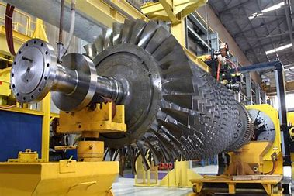
Figure1.1.1. Turbine Systems

CHAPTER – II
LITERATURE REVIEW
Authors:. Larsen, Lena
Journal: (Master's thesis, University of Stavanger, Norway).
Title: Drill string vibration is a widely studied topic
Drill string vibration is a widely studied topic. This paper developed a real-time measurement system near the drilling bit and extracted the lateral vibration, longitudinal vibration time series of bottom rotating drill string. In order to reconstruct the phase space, we estimated the delay time with mutual information and calculated the embedding dimension through Cao’s method. Finally, the chaotic characterization of the system is analyzed by calculating the correlation dimension and the largest Lyapunov exponent. The results show that such system can exhibit positive finite-time Lyapunov exponents and a clear convergence toward the correlation dimension, which is a strong indicator for the chaotic behavior of the system. It is expected that the new dynamics found in this paper could be of potential implication to the control methods of the drill string vibration.
The results of research into the impact strength of rock using a “Protodyakonov” type drop hammer apparatus are reported. The size of the original apparatus and the volume of charge required are critically discussed and modified to allow the testing of small fragments of size 4-8 mm. The new modified versi on of the apparatus, referred to as the “Small Drop Hammer”, is then used to determine the ROCK IMPACT HARDNESS NUMBER (RIHN) of crushed rock particles and drill cuttings. The drill cuttings results are shown to be erratic and, therefore, can not be used for accurate prediction of drill performance.
Authors: Rolla, Missouri.
Journal: Chaotic vibration analysis of the bottom rotating drill string.
Title: An Empirical Equation For Drill Performance Prediction .
The average field drilling rate of a rock is related to the power input in terms of operating pressure, the RIHN and the shore hardness of fresh pieces of the rock collected from the quarry face. An empirical equation is proposed and shown to be adequate for predicting drilling rates for both down-the-hole and drifter drills.
The ability to predict the performance of rock drills is important in drilling operations. Contractors could use prediction equations to estimate the total drilling costs of a venture, and the drilling machine best suited for a particular rock type and working conditions could be then selected. The manufacturer could use prediction equations to check improvements in the design of existing drills.
In the past, the compressive strength of a rock was used to predict the drilling rates of a particular rock. Experience, however, has shown that some rocks with high values of compressive strength can be drilled at faster rates than the compressive strength value indicates. Laboratory developed “Drillability Equations” give gross errors when used to evaluate the field machine performance (1,2). This is because such equations are determined under conditions that are entirely different from field situations.
Field drilling coupled with the collection of drill cuttings has received cursory attention in the literature. This paper examines the use of drill cuttings results to evaluate the possibility of arriving at an index of drillability.
The average drilling rate at a particular operating pressure of a number of drill holes is related to the physical properties most pertinent to the percussive drilling mechanism, by an empirical equation.
Authors: NWAMAIFE OLUCHUKWU DANIEL.
Journal: SE ADEWOLE. "SURVEY OF HORIZONTAL WELL SUCCESSES." (2023).
Title: SURVEY OF HORIZONTAL WELL SUCCESSES

Horizontal drilling has become a key technology used to reduce costs and enhance recoveries from producing reservoirs. Through 2001, commercial databases contained records on 34,777 horizontal wells from 72 countries. Canada (18,005wells) and the United States (11,344 wells) were the leading countries for horizontal drilling. More than 5400 horizontal wells were recorded outside of North America. Russia, Venezuela, Oman, United Arab Emirates, Nigeria, Saudi Arabia, and Indonesia were the leading countries in terms of numbers of wells. Wells drilled by major operators (Bp, Cheveron, Conphil, Eni, Shell and Total) and independent operators (Anadarke, Apache, Hess, Maersk, Marathon, Murphy, Noble, Oxy, Repsol, Talisma) where discussed in this research. Wells drilled in Hassi R’Mel Oil Rim , Algeria used in oil reservoir recovery were discussed.
Authors:James
Journal: . In ARMA US Rock Mechanics/Geomechanics Symposium
Title: The Petroleum Engineering Handbook
The Petroleum Engineering Handbook, Volume II: Drilling Engineering is a comprehensive reference book published by the Society of Petroleum Engineers (SPE). It is part of a multi-volume series that provides in-depth information about various aspects of petroleum engineering. Volume II, specifically focused on drilling engineering, covers a wide range of topics related to the drilling process in the oil and gas industry.
Authors: Guoshuai Wang,
Journal: ACS Applied Nano Materials 2021
Title: Gr-Al₂O₃ Nanoparticles-Based Multifunctional Drilling Fluid
Various chemical additives are used in drilling fluids to improve drilling efficiency and increase oil production. Dispersing nanoparticles as additives in drilling mud is one of the more promising techniques that could help solve many difficulties of drilling operations. However, the existing research in this field is insufficient and suffers from numerous inconsistent outcomes. This study aims to discover and evaluate the impact of graphite-alumina hybrid nanoparticles on the rheology, thermal properties, zeta potential, and electrical conductivity of water-based drilling fluids. This study shows that that the addition of nanoparticles improves the effectiveness of water-based mud (WBM), both in static and dynamic situations due to the establishment of an appropriate gel structure that can be easily broken under low shear stress. Furthermore, these nanoparticles improve the degree and the speed of structural recovery by reducing the relaxation time, which is necessary to avoid the sedimentation of weighting materials and drilled cuttings. Besides, nanoparticle seeded fluid improves the effective thermal conductivity of conventional drilling fluids, and the highly charged suspension resulting from the addition of nanoparticles is desirable for drilling operations. It is also observed that nanoparticles could penetrate through the porous wall of the wellbore and clog the pores, forming a thin and impermeable cake that reduces drilling fluid loss

Authors Sandia.
Journal: . Society of Petroleum Engineering (SPE).
Title: Handbook of Best Practices for Geothermal Drilling
.
This Handbook is a description of the complex process that comprises drilling a geothermal well. The focus of the detailed Chapters covering various aspects of the process (casing design, cementing, logging and instrumentation, etc) is on techniques and hardware that have proven successful in geothermal reservoirs around the world. The Handbook will eventually be linked to the GIA web site, with the hope and expectation that it can be continually updated as new methods are demonstrated or proven.
Authors: Larsen, L.
Journal: multifunctional drilling fluid. Industrial & Engineering Chemistry Research.
Title: Tools and techniques to minimize shock and vibration to the bottom hole assembly.
When drilling a well there is a risk of serious damage caused by drillstring vibrations. Shock and vibration are identified as a cause of premature failure on drill bit and components in the bottom hole assembly (BHA), resulting in lost time for operators and costing service companies several millions in repair each year. The expenditures incurred by drillstring vibrations include reduced rate of penetration (ROP), tripping and poor drilling performance. Currently, several tools and techniques are used in the attempt to minimize shock and vibration. For vibration mitigation to be more effective in the future, the most effective tools and techniques must be designated, implemented and improved. The main objectives of this thesis are to give an insight into the main vibration problem and determine effective mitigation tools and techniques, with regards to the BHA design, which can minimize shock and vibration, and improve the drilling performance in the future. A particular focus was given to anti-vibration tools, and vibration prevention in underreamer applications. The thesis is divided into four main parts; theory on drillstring vibrations, evaluation of various tools and techniques for vibration mitigation, including supplier input, a performance analysis of the Anti Stick-slip Technology (AST) and finally a discussion and conclusion part. Several field case studies are presented to illustrate how the tools and techniques can reduce the risk of detrimental vibrations. The work is based on literature reviews and is substantiated by comparative field experiences. Additional information was acquired through conversations with Statoil, the directional drilling suppliers and tool suppliers. These conversations proved highly valuable and resulted in several proposed tools and techniques that should be considered when designing the BHA. The thesis revealed that BHA design awareness can lead to huge advancements in terms of minimizing shock and vibration. Roller reamers should be added to the assembly if high stick-slip levels are expected or if the stabilizers experience extensive friction. Anti-vibration tools, such as AST and Frank´s Harmonic Isolation (HI) tool should be considered, as field experience indicates that these tools can reduce the vibration level.
Authors: F.RODNEY
Journal: Sandia National Lab.(SNL-NM), Albuquerque, NM (United States)
Title: measurement-while-drilling (MWD) resistivity logging tool.
This paper is an overview of the development of a 2-MHz [2×10⁶-cycle/sec] measurement-while-drilling (MWD) resistivity logging tool. This tool uses propagating electromagnetic waves rather than the pseudostatic fields of its low-frequency counterparts. The basic theory of operation is presented along with a discussion of the factors that affect tool response and the compromises that led to the specific embodiment. Field data are presented from which a comparison is made between this tool and wireline tools. It is seen that it is often possible to obtain a direct reading of true formation resistivity, Rt, with this tool.
Authors: Huibin Zhao
Journal: (Master's thesis, University of Stavanger, Norway).
Title: mproving the application depth of electromagnetic measurement while drilling (EM-MWD) systems by receiving signals from adjacent wells

EM-MWD systems transmi ia an information channel composed of drill string and formation, and the formation has a strong attenuation effect on the signal. in EM wave transmission in the formation limits the application well depth. This paper discusses several commonly used methods to improve the depth of EM-MWD applications, including turbine power supplies, adaptive ,. transmitting antenna extensions, and repeater. . Based on both theory and practice, the characteristics of these methods are analyzed. An EM-MWD system in which signals are received from an adjacent well is proposed, and a formula for calculating the receiving voltage for an adjacent well is derived based on a model of this system. According to this formula, the proposed EM-MWD system can greatly increase the receiving voltage, where deeper adjacent wells provide a greater increase in the receiving voltage and a greater maximum transmission depth for the EM-MWD system. In-hole experiments of this EM-MWD system based on signals received from an adjacent well demonstrate that this method can effectively increase the voltage of the received signals on the ground, in agreement with theoretical results.
Authors: SANDRA BLEUE.
Journal: SPE Drilling Engineering
Title:Borehole logging in the mining environment.
The examples shown in this article illustrate the possibilities for the integration of diverse data sets that can reduce the risk of misinterpretation and help to meet the objectives of an eco-friendlier industry. The multiple and overlapping usages of surface exploration methods provide real solutions to real exploration issues. The “petro” in Petrophysics means “rock”, not “petroleum”! The right kind of rock is what mining engineers, management, and shareholders are looking for. It is time to integrate all our petrophysical / geoscience skills to find those deeper prospects we know must be out there. Our world depends on our success.
Authors:Antony.A
Journal: (EM-MWD) systems by receiving signals from adjacent wells. Journal of Applied Geophysics
Title: A geoscientist's guide to petrophysics
For this article, we are expanding the definition of petrophysics to include the exploration methods performed on or near the surface to locate potential ore bodies, using all the physical principles from oilfield well logging experiences. The next article, the last in our Green Economy Series, covers borehole logging in the mining environment.
Authors: , San Antonio.
Journal: The Concept of Digital Entrepreneurial Ecosystem for SMEs in North Sulawesi, Indoesia
Title: Improved BHA Sag Correction and Uncertainty Evaluation Brings Value to Wellbore Placement.
Recent well positioning uncertainties evaluation per SPE published ISCWSA model for MWD survey tools suggests that 80% of the inclination measurement error budget is a consequence of BHA sag.
BHA sag is the misalignment of the directional sensor with the borehole direction due to deflection of the MWD drill collar under gravity and borehole curvature. The magnitude of the error depends on BHA type and geometry, sensor spacing, hole size and several other factors.
This paper presents a new methodology based on modern 3D BHA/Hole interacting modeling for BHA sag corrections and residual error evaluation at each MWD survey stations.
11 different typical 17½" and 12¼" rotary and steerable motor BHA's with variable gauge stabilizers were computed in multiple configurations (borehole geometry, BHA settings, friction…) following a Monte Carlo process which involved more than a million simulations. Results of this study show that the residual BHA sag uncertainty as proposed by the ISCWSA model can be further reduced by as much as 50%.
A simplified software automated process was developed in order that Operations Support Centres can easily integrate the proposed methodology as part of near real time Survey Management advanced processing routines.
A sound BHA sag correction method along with a thoroughly analysed residual sag error, readily fit for use within the ISCWSA MWD well positioning uncertainty model (today's industry standard), appears essential in a wide variety of directional drilling applications including extended reach and horizontal drilling.
Authors: L Macresy
Journal: MWD Electromagnetic Wave Transmission Method.
Title: Improved BHA Sag Correction and Uncertainty Evaluation Brings Value to Wellbore Placement.
Recent well positioning uncertainties evaluation per SPE published ISCWSA model for
MWD survey tools suggests that 80% of the inclination measurement error budget is a
consequence of BHA sag. BHA sag is the misalignment of the directional sensor with the
borehole direction due to deflection of the MWD drill collar under gravity and borehole
curvature. The magnitude of the error depends on BHA type and geometry, sensor spacing,
hole size and several other factors. This paper presents a new methodology based on the MWD.
Authors: FR Florence

Journal: CRAIN, E., BLEUE, S., & INC, P. O. METALLIC MINERALS.
Title: New surface and down-hole sensors needed for oil and gas drilling.
The history of oilwell drilling includes a number of innovative techniques to infer the conditions down-hole and their impact on drilling performance. Surface and down-hole sensors have been deployed to measure related physical phenomena that can be generally associated with the actual environment. Some direct measurements have been made after drilling using sensors suspended on a wire line, and this evolved into near real-time measurements using Measurement While Drilling (MWD) and Logging While Drilling (LWD) equipment that use low bandwidth pulse telemetry communications. With the advent to high speed wired drillpipe, new sensors are needed to take advantage of the improved telemetry capabilities to produce true real-time measurements. New surface sensors are needed that employ smart technologies and enhanced data processing. By combining these high-speed, high quality measurements with predictive models, set points and limits can be directly connected to the latest generation of open-architecture rig control systems to improve drilling safety and efficiency. This paper briefly outlines the shortcomings of a wide variety of existing sensor designs and identifies emerging technologies that could provide better measurements if the harsh environmental constraints can be met. The authors then call to non-industry participants to adapt sensor technologies used in other commercial applications to help automate the process of drilling for oil and gas. They discuss where the oil and gas industry needs accurate, real-time measurements of chemical, rheological and physical properties, and how these measurements could be used. They also address the need for power generation and/or storage to overcome challenges encountered today. The paper ends with a look ahead as the industry seeks new sensors, perhaps based upon a very different set of physical measurements that will improve our ability to safely produce oil and gas until alternate energy sources become commonplace.
Authors: Kes J Heffer, Richard J Fox, Colin A McGill, Nick C Koutsabeloulis
Journal: A geoscientist's guide to petrophysics. Editions Technip..
Title: Fault structure and geomechanical changes in mature waterfloods.
Recent studies have revealed a strong correlation between the directionality of reservoir flow in waterfloods and the local orientation of horizontal earth stresses. Field applications are described of a novel technique of determining interaction between wells as a potential indicator of flow directionality. This technique calculates the Spearman rank correlation coefficient between flow rates at pairs of wells. These applications have demonstrated that the reservoir dynamics associated with correlated rate fluctuations have at least some component coupled to geomechanics. Coupled geomechanical-fluid flow numerical modelling is able to explain some of the observations and offers an improved predictive tool for planning and managing waterfloods and determining optimal locations for infill wells.
Authors:Jhon davit
Journal: In SPE Annual Technical Conference and Exhibition.
Title: FILTRATION PROPERTIES OF WATER BASED DRILLING FLUIDS
This thesis reports an experimental and theoretical study on filtration properties of water based drilling fluids under dynamic and static conditions. The tested muds cover Freshwater/Gypsum/Lignosulphonate mud and SeawaterlKCLlPolymer mud, barite weighted and unweighted. The effects of the solid concentration, pressure and shear rate on the filter cake characteristics and the erodability were investigated. For static filtration experiments, all tests were conducted for two hours and the spurt loss, the filter cake thickness, the ratio of wet to dry cake mass and the cumulative filtrate volume against time were measured. For dynamic filtration experiments, however, only the spurt loss and the cumulative filtrate volume against time were measured and all tests were conducted for at least 8 hours. A general filtration equation was developed based on the cake filtration theory prevailing in the chemical engineering industry and it was utilised to obtain the modified classic static filtration equation and the dynamic filtration equation. The modified classic static filtration equation was then employed to fit the static filtration experimental data and the average specific static cake resistance and the effective filter medium resistance were calculated. The dynamic filtration equation showed a substantial agreement with the dynamic filtration experimental data. Using the static filter cake properties such as the ratio of wet to dry cake mass (m), the average specific dynamic cake resistance, the effective filter medium resistance and the dynamic filter cake erodability were calculated. In the study of the relationship between the static filtration data and the dynamic filtration data, an attempt of predicting the dynamic filtration data from the static filtration experimental data was conducted. Also, an attempt was carried out to predict the static filtration data and the dynamic filtration data in a sequential process.
Authors: Nguyen, Cuong
Journal: In SPE Annual Technical Conference and Exhibition, San Antonio, Texas, USA, September.
Title: A study of underbalanced drilling application for granite basements in Vietnam.
Underbalanced drilling (UBD) has gained popularity during the recent years as it provides a method to prevent formation damage, minimize lost circulation risks, and increase the rate of penetration. However, drilling with a bottomhole pressure less than the formation pore pressure will often increase the risk of borehole instability due to the shear or compression failure of the rock adjacent to the wellbore. The extent of rock failure is related directly to the pressure in the annulus between the drillpipe, collars and the wellbore which can only be calculated through modelling multiphase flow in the drilling system. The relationship between rock failure and wellbore hydraulics becomes more complex due to the appearance of the influx formation fluid in UBD. Therefore, the aim of this research is to describe methods to solve the complex interaction of wellbore stability, rock yielding, collapse, wellbore hydraulics, and production capacity during UBD operations. To achieve the aim, analytical and numerical solutions have been codified into two programs WELLST, and UBDRILL. Commercial software packages such as ABAQUS, PERFORM, HYMOD were also used to model the process. Field data from granite basement reservoirs of Basin X, Vietnam were used as the parameters input into the model to calculate. This research includes: • An analysis of the influences of time dependence, thermal and hydraulic diffusivity, wellbore pressure changes, inclination and azimuth variation, poroelastic and thermo-poroelastic deformation, cooling and heating effects on wellbore stability in UBD. • An analysis of pressure, temperature, fluid properties distribution in the annulus and inside the drillpipe while UBD. • An analysis of the suggested liquid gas rate window (LGRW) which gives field engineers flexibility in the selection of liquid and gas injection rates on the drilling site when UBD is applied. • An estimation of production capacity in UBD operations. These results were obtained by analyzing the field data of granite basement formations and clastic formations of Basin X, Vietnam which is under compression in a strike-slip environment.
Authors: Mohd. Ramzan.
Journal: In 2012 IEEE International Instrumentation and Measurement Technology Conference Proceedings (pp. 670-675). IEEE.F.
Title: Education for Offshore Engineering and Application to a Platform Design.
This thesis considers some of the patterns and requirements of education available in the United Kingdom for offshore engineering at the level of first degree and postgraduate courses. These requirements are illustrated by a design study for an offshore oil platform and associated steel jacket for waters east of West Malaysia in the South China Sea. Proposals are then made for courses in offshore engineering suitable for Malaysia. The first part of the thesis traces the rise of the offshore industry which is mainly the offshore oil industry and the growth of tertiary education for this industry. It draws attention to the breadth of interests required and the absence of undergraduate courses which treat offshore engineering as a totally distinct branch of engineering under the accreditation procedure of a professional engineering institution. Demand is met by courses which represent sub-specialisation for students who begin in other branch of engineering. A similar pattern exist in the postgraduate education which if anything draws from a wider background. Design of an offshore oil production platform illustrates the breadth of education required although the thesis limits numerical consideration to the design of steel lattice jacket under operational and environmental loadings. The relatively shallow water off the Malaysian coast is less severe compared to the North Sea. The oil industry requires manpower at all levels of expertise and the last part of the thesis considers a pattern for this education for technicians, professional and postgraduate engineers
Authors: Zarei, Faraj
Journal: Edinburgh EH14 4AS, UK. Understanding the Micro to Macro Behaviour of Rock-fluid Systems.
Title: Optimal scheduling of field activities using constraint satisfaction problem theory
The challenge of identifying problematic wells and planning their workover operations is common in oil and gas fields. On top of this, the well intervention resources are seldom easily accessible so it is crucial to target the right set of wells at the right time. Oil and gas reservoirs are complex dynamic systems the production and injection patterns of which can significantly affect the reservoir and well response. This represents a complex mathematical optimisation problem where the overall life performance of the field strongly depends on the workover planning decisions. This work presents a reliable and effective tool that is able to screen and explore the large search space of the potential work-overs that adds value to the reservoir management process. The proposed solution considers the overall performance of the field throughout a specified period while respecting all operational limitations as well as considering the risks and costs of the interventions. The proposed workflow combines the commercial optimiser techniques with constraint satisfaction problem optimiser to identify the optimal workover scheduling. The schedule found is guaranteed to satisfy all predefined field constraints. The presented results showed better performance achieved by the proposed hybrid Algorithm in maximising the defined objective function. The suggested workflow can greatly enhance the decisions related to field development and asset management involved with large number of wells and with limited intervention resource.
Authors: VISWASANTHI CHANDRA
Journal: Institute of Petroleum Engineering
Title: IMPROVING RESERVOIR CHARACTERISATION AND SIMULATION USING NEAR-WELLBORE UPSCALING.
The copyright in this thesis is owned by the author. Any quotation from the thesis or use of any of the information contained in it must acknowledge this thesis as the source of the quotation In this thesis, novel workflows involving high resolution near-wellbore modelling (NWM) are illustrated, which allow integration of multi-scale geological and petrophysical data from highly heterogeneous reservoirs in field-scale reservoir simulations. When applied to a clastic reservoir with high variance at small scale, NWM significantly improved reservoir characterisation and calibration of reservoir model with well test data. Results show that using NWM tools for reservoir modelling yields more precise flow calculations and improves our fundamental understanding of the interactions between the reservoir and the wellbore. Furthermore, this thesis employs an integrated NWM workflow to identify and evaluate the geological heterogeneities that enhanced reservoir permeability in a giant carbonate reservoir with a long production history. Key among these heterogeneities are mechanically weak zones of solution-enhanced porosity, leached stylolites and associated tension gashes, which were developed during late stage diagenetic corrosion. The results of this investigation confirmed the critical role of diagenetic corrosion in enhancing the permeability of the reservoir. One of the key aims of this thesis is to develop a novel near-wellbore upscaling (NWU) workflow that addresses the challenges associated with conventional carbonate modelling workflows. The NWU workflow developed in this thesis provides a systematic geostatistical approach to obtain more realistic representation of the above multi-scale geological-petrophysical heterogeneities in the reservoir simulation model of the carbonate field. The NWU results were used to generate global porosity-permeability and vertical-horizontal permeability relationships for reservoir simulation. Instead of applying artificial permeability multipliers that do not necessarily capture the impacts of geological heterogeneities, the NWU workflow incorporates representations of fine-scale heterogeneities in the reservoir simulation model.Another aim of this thesis is to develop a new near-wellbore rock-typing and upscaling approach to improve the integration of reservoir rock-typing and simulation in carbonate reservoirs. The rock-typing and upscaling methodology described in this work involves the geological-petrophysical classification of the reservoir heterogeneities through systematic evaluation of the key diagenetic events, including the key associations between the depositional and diagenetic features, and their impact

ivon reservoir flow properties. The near-wellbore rock-typing and upscaling workflow yielded consistent initialisation of the reservoir simulation model and therefore improved the calculation of volumes of fluids-in-place. Subsequently, the cumulative production curves computed by the reservoir simulation model agreed well with the historic production data. The revised simulation model is now much better constrained to the reservoir geology and provides an improved geological-prior for history matching.

Authors: Wang, Fei.
Journal: (Doctoral dissertation, Heriot-Watt University).
Title: Processing and analysis of transient pressure from permanent down-hole gauges
With the permanent down-hole gauge (PDG) widely installed in oilfields around the world in recent years, a continuous stream of transient pressure data in real time are available, which motivates a new round of research interests in further developing pressure transient analysis techniques. PDG data is recorded under the unconstrained circumstances, so that it cannot avoid effects due to noise, rate fluctuation and interference from other wells. These effects make the measured pressure trends declining or rising and then obscure or distort the traditional flow behavior, which makes the following analysis difficult. In this thesis, the problems encountered in analysis of PDG transient pressure are investigated. A new algorithm, multi-well deconvolution, and corresponding computer codes are developed. The algorithm is based on linear recursion with added non-linear least squares optimization to deal with the noise problem in time domain. With this developed algorithm, the inter-well interference effect can be extracted and the variable-rate superposition effect can be solved at the same time. New deconvolution-based rate transient analysis and pressure transient analysis methods are both proposed in this thesis. Numerical well testing synthetic studies are performed to demonstrate these procedures. The results prove that the new method works well in homogeneous reservoirs with two wells flowing at single phase, multiple rates.

Authors: Khalid Mohammed M Alruwaili
Journal: Education for Offshore Engineering and Application to a Platform Design .
Title: Continuum and Combined Continuum-Discontinuum Analysis of Wellbore Mechanics and Stimulation Response.

Wellbore drilling and stimulation activities are interlinked processes within the task of borehole construction. Before drilling a well, the initial stress state in the rock can be defined by three principal stresses, with a typical assumption that these consist of the vertical stress (σv), the maximum horizontal stress (σH) and the minimum horizontal stress (σh). After drilling, the stress state changes around the created borehole. The fundamental engineering problem then is to calculate the stresses around the created borehole and/or at the borehole’s wall. Numerous analytical and numerical models exist to estimate the stresses around a circular hole, but these models cannot explain the observed phenomena either in the field or the lab. Attention here is focused on models that are commonly used to predict the stress state around a circular opening. These models do not account for the sequence of the physical processes, leading to an inadequate stress state estimation. This research investigates the 2D classical analytical method, along with a comparison of that approach against numerical methods. This investigation reveals that the models are not equivalent. This is not because of mathematical issues, but is due to the fact that the mechanical systems expressed by these models are not equivalent. The drilling model captures the physics of the real process which makes it possible to explain some phenomena observed in field and laboratory tests. The drilling model approach is applied for several sedimentary rock examples. The combined continuum-discontinuum method reveals its capability in calculating rock failure and deformation that is comparable to some published laboratory drilling tests. Also, the simulation results shed light into the complex fracture growth regime around the wellbore. Drilling and Hydraulic fracture simulation is carried out for Berea sandstone using both the continuum and the combined continuum discontinuum methods. The results are in good agreement which identifies a practical engineering method for larger models. The fracturing initiates in Mode II (shear) near the circumference of the wellbore aligned with the maximum stress. At later stages, Mode I (tensile) fractures also develop and propagate the fracture parallel to the maximum horizontal stress. This fracturing mechanism continues for as long as the pressure is applied.

Data Transmission in MWD

The MWD offers the real-time data. The logging curve is obtained in the case of a slight invasion or even no invasion of the ground fluid, so it is closer to the real situation of the ground. Measurement While Drilling (MWD) is an advanced technique in directional drilling, which can measure the information about the bottom of the drill hole without interruption, and send the information to the surface instantly.
Basic two ways of data transmission from bottom hole to the surface are:

  - Wired Transmission
  - Wireless Transmission
Wired Transmission - Wired transmission requires a connection between the source (located at subsurface and the receiver (located at surface). It is mainly divided into two categories- Cable Transmission and Drill pipe transmission.

Cable Transmission - In cable transmission the signal goes down the inside of the drill pipe to the electrical conductor. As the hole deepens cables and other instruments needed to be pulled out to make the connections. The closing device is similar to a three way, whose upper and lower ends are connected to the drill strings and the third way provides a lateral passage through which the cable line can move from inside the drill string to the outside.
Data transmission using the closing device is the most popular method. The closing device is similar to a three way, whose upper and lower ends are connected to the drill strings and the third way provides a lateral passage through which the cable line can move from inside the drill string to the outside.

This method is effective when the drill string does not rotate during drilling.

Advantages of Cable Transmission-
    - High Transmission Rate
    - Bi directional information network

Disadvantages of Cable Transmission
    - Very complex process and inhibit the drilling process (increases the trip time).

Special Drill pipe Transmission
    - Assessor located at drill collar
    - The Armoured cable provides the connection between the drill collar and the bottom of the drill pipe.
    - An insulated slip ring is installed at the top of cally bar an
    - The ring is connected to the ground equipment.

The drill pipe joints play an important role in data transmission. An induction coil at both ends of the drill string. The coils transmit data to adjacent joint coils. The drill pipe uses copper wire as the conductor, and the transmission power is generated by the underground hardware power source.
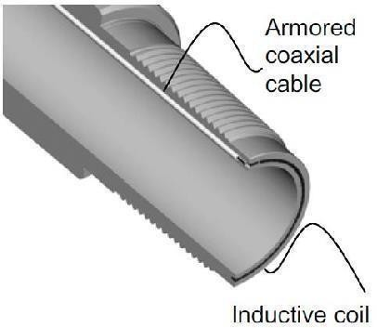
Figure.3.1 Special Drill pipe with cable

Advantages of Special Drill pipe Transmission
    - High Transmission Rate
    - Bi directional information network
    - Doesn’t inhibit drilling and connection process.

Disadvantages of Special Drill pipe Transmission
    - Special drill pipe is required, which makes it very costly.
    - Sometimes connections at the joints are not continuous, which makes it less reliable.
    - Transmission of power from surface to bottom hole is also difficult.

Wireless Transmission

Wireless Transmission doesn’t require a connection between the source (located at subsurface and the receiver (located at surface). It is mainly divided into four categories- Mud Pulse Transmission, Electromagnetic Transmission, Sound Wave Transmission and Mixed Measurement.

Mud Pulse Transmission
This is most widely used wireless transmission. The system conveys down hole information by means of hydraulic communication channel (mud flow). The mud used for transmission should be completely incompressible because if gas or air is present in the mud no pulse will travel to the surface.

This system transmits the data in three ways- positive pulse, negative pulse and continuous wave

Advantages of Mud Pulse Transmission
    - Cost effective process
    - Doesn’t inhibit trip time

Disadvantages of Mud Pulse Transmission
    - Less amount of data is transmitted
    - low transmission rate

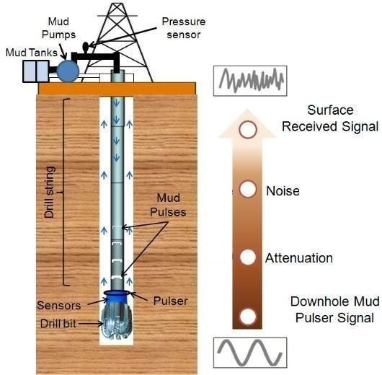

Figure.3.2 Mud Pulse Transmission overview

Electromagnetic Transmission

The electromagnetic wave signal transmission is mainly realized by the formation medium. The down hole instrument loads the measured data onto the carrier signal, and the measurement signal is transmitted from the electromagnetic wave transmitter to the surrounding with the carrier signal.

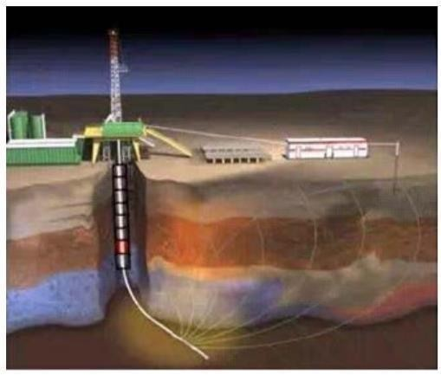

Figure.3.3 Electromagnetic Transmission

Advantages of Electromagnetic Transmission
    - High transmission rate
    - Unaffected by mud and can be run in in air drilling, laser drilling etc.
    - Can be applied environment of high lost circulation.

Disadvantages of Electromagnetic Transmission
    - Formation medium has a great influence on the signal.
    - Limited transmission distance, so not suitable for deep wells
    - High attenuation rate
.

Sound Wave Transmission
In this mode signal from bottom hole to surface are sent in form of sound wave of seismic wave through formation or drill string. The instrument transmits the binary code pulses representing the underground parameters to the control circuit, which sends the acoustic wave vibration signals. The signals are transmitted along the drill string or the tubing to the ground.

Advantages of Sound Wave Transmission
- Don’t need mud circulation, so can be run in in air drilling, laser drilling etc.
- High Transmission rate
- Cost Effective and easy to operate

Disadvantages of Sound Wave Transmission
- Low transmission rate
- High attenuation rate
- Intensity of signal is very low, so badly affected by borehole and surface noise

Mixed Measurement
A system with two transmission modes- Electromagnetic and Mud pulse. In this system the drawback of one mode is reduced by the efficiency of the other, which improves the reliability and efficiency of the data.
Table: 3.1 Comparison of Various modes of data transmission

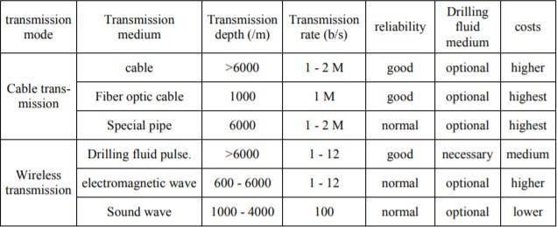

- MPT System Signal Impairments

Mud channel signals experience pressure fluctuations and uncertainty caused by various MPT system components that potentially change signal properties during the course of data transmission. The main noise sources that induce pressure fluctuations are mud pumps, pulsation dampeners, surface piping, pressure transducer locations, drill string components, mud properties and the well depth. The mud channel that the pulse signals pass as they propagate to the surface is extremely harsh, demanding complex surface signal detection and extraction. Common mud pulse signal property distortions which degrade signal transmission and data rates are downhole signal strength, signal attenuation, surface induced noise (electrical noise) and surface piping induced signal reflections. Unpredictable and complex adjustable signal impairments are caused by drilling noise, drill string motion noise within the borehole, attenuation and circulation pumps noise. Depending on the severity of the mud channel conditions and signal distortions, to achieve maximum possible data rates, telemetry systems must be robust and flexible, both downhole and at the surface receiver. Despite the signal processing complexity and their varying properties, mud pulse systems must adapt the harsh working environment and recover the useful original signals. This section discusses main mud pulse telemetry system signal impairments that affect MPT data transmissions.

MPT Mud Pump Noises
During mud pulse signal transmission, mud pumps generate down-going mud flow which creates pressure signals by simultaneously opening and closing intake and exhaust valves and moving a piston back and forward within a cylinder. Reciprocating motion of mud pump pistons generates pump signals propagating downstream in opposite direction from the downhole pulse information carrying signal wave. Forcing mud through the exhaust valve create mud pressure variations which pass through the surface transducer down the drill string to the drill bit and results into cumbersome mud pump noise signals. Despite pressure random noise and signal interferences, generated mud pump pressure fluctuations create notable signal amplitude and frequency variations within the frequency ranges 1–

20Hz, commonly used for LWD data telemetry systems. The MPT pulse signal is lost in the pump noise which affects surface pressure transducers as are located close to mud pumps than to the mud pressure pulsar generators. Mud pump noises have frequency magnitude greater than the original l pulse pressure signal waves, causing difficult correct signal extractions.
The frequencies at which pump noise tones occur are harmonic in nature and appears as set of frequency integers that are multiples of pump stroke rates fundamental frequency, e.g., 3F, 6F, 9F, etc, that can be estimated by an equation. To minimize the effect of this noise, it is possible to predict on which frequency the harmonics will appear using the following equation.
fn = (n*s)/60
where fn is the frequency of the nth harmonic. s is the pump stroke rate, stroke/minute, and n is the Harmonic number, n ∈ {1,2, 3,…}

MPT Signal Attenuation and Dispersion
As MPT system signals propagate through the drilling mud along the borehole, signals are attenuated and dispersed. This is caused by underbalanced drilling mud which results into viscous dissipation and frictional energy loss at the borehole walls. To minimize reservoir damage, the drilling mud pressure is kept high that exceeds the hydrostatic pressure and nitrogen gas is used to reduce mud density. The effect increases the drilling mud compressibility hence reducing mud bulk modulus and mud pulse propagation velocity in the drilling fluid. Changes in drilling mud compressibility may result into serious earth formation damage which strongly affects the shape of the signal pulses and complicates the decoding process. Factors influencing mud pulse signal attenuation include the borehole depth, drilling mud type, number of joints in the drill string, drill string inner diameter and signal operating frequency. Attenuation impacts may not be constant across the range of frequency components, lower frequency components are subject to less attenuation than higher frequencies. Devising good control of the various noise sources in 1–20Hz frequency band, it is advantageous to transmit MPT data at the lowest possible frequency to minimize the signal attenuation impacts. In high data rate exploration and drilling operation
applications, the effect of signal attenuation is not the major burden but rather the various noise sources and their distribution across the available channel transmission band.

Signal Echoes and Reflections
High data rate pulsars in MPT telemetry not only create signals that propagate uphole, but also reverse direction, down-going signals that reflect at the drill bit which combine to create constructively or destructively interfering signals. Strong signal reflections are detected at the surface signal detectors caused by mud pumps, pulsation dampeners, drill string joints and diameter changes, dispersion and filtering of certain frequencies within mud channel. The ultimate signal that travels up the drill pipe depends on mud velocity, the position of the pulsar in the drill collar, operating frequency and the bottomhole assembly details forming the host waveguide. The superposition of the main wave from the transmitter and the multiple reflected waves generate either destructive interference or constructive interference pulse signals. Destructive interference signal can severely limit data rate and transmission distance while the constructive interference signal, if properly applied, can enhance LWD signal strength without the power penalties incurred by mechanical methods. As a matter of fact, signal reflections occur at any impedance mismatch positions in drill string, reducing its impacts proposed novel multiple-echo suppression model using two receivers based on the transient pulse responses in uplink and downlink channels.

Drill String Rock Formation and Gas
The rock formation solid particles, free gas volume fraction and mud channel compressibility significantly affect the mud pulse velocity and signal attenuation. Solid particles caused by the rock formation that are destroyed during the drilling process, form formation fragments of different sizes and the gas may enter the borehole when a high- pressure zone is being penetrated . As mud solids and the free gas content increases, mud density and mud compressibility changes decrease the mud pulse velocity which adds complexity to signal transmission speed. The initial mud pulse propagation velocity calculation models considered drilling mud to be a single phase; however, drilling mud is a multiphase, containing clay, formation cuttings of various sizes, barite, and free gas mixed

with water or oil, all affecting the mud bulk modulus. Drilling mud borehole boundary constraint study using mud pulse velocity continuity derived equation shows that water- based mud velocity is generally higher than oil-based mud. If gas influx is not offset in time, the unstable effect can escalate into well blowout creating severe financial losses, environmental contamination, and even potential human lives loss.

Downhole Random Noise (Electrical Motor)
Downhole sources of random noise are the pressure fluctuations caused by bit vibration, drilling motor stalling and the drill bit interaction with formation being drilled.
These noises present the band-limited white Gaussian noise due to the lower noise frequency spectrum. Although the random noise frequencies are small but they can affect certain signal frequency bands, causing relatively larger random pressure amplitude fluctuations and may lower downhole signal-to-noise ratio (SNR). Mechanical rig vibration and electrical noise coupling into the electrical wiring that carries the electrical signals from the drilling sensors to the signal receiver may degrade telemetry signal detection and extraction. These noises present the band-limited white Gaussian noise due to the lower noise frequency spectrum. Although the random noise frequencies are small but they can affect certain signal frequency bands, causing relatively larger random pressure amplitude fluctuations and may lower downhole signal-to-noise ratio (SNR).

Signal impairments degrade the quality of the surface received signal and complicate telemetry signal detection and extraction. These noises present the band-limited white Gaussian noise due to the lower noise frequency spectrum. Consequently, methods and techniques to recover the transmitted downhole signal at the surface are becoming key problems for LWD mud pulse systems.

Introduction to Sensors
The sensors in oil and gas industry is segmented by sensor type ( gas sensor, temperature sensor, ultrasonic sensor, flow sensor and level sensor), connectivity ( wired and wireless), oil and gas industry activity (upstream, midstream, downstream), geography. The sensors used can be classified into two types-

Analog Sensors – These are sensors that produce results in continuous output signal or voltage and then converted to preferred engineering quantity, which is generally proportional to the voltage signals being measured. Few analog sensors used in oil and gas industry are Hook load sensors and Standpipe pressure Sensors.

Digital Sensors – These are sensors where data is digitally converted and transmitted. This type of sensors are often used for analytical measurements. Typically measured parameters are resistivity, RPM, SPM etc. Draw work sensors and Pump stroke sensors are few examples of digital sensors used in oil and gas industry.
MWD Sensors - All sensors used in the downhole tool must be rugged enough to withstand the harsh environment. Only one of the systems currently available has the facility to change-out damaged components (sensor package/electronics) without tripping the whole bottom hole assembly out of the hole. The failure of one sensor may not necessarily mean that the tool has to be pulled out. If the operator is satisfied that the other sensors are still providing the required information, the loss of one piece of data may not be significant.

Directional sensors for measuring inclination and azimuth
The directional sensors currently being used in MWD tools are triaxial magnetometers and accelerometers similar to those used in steering tools. These sensors measure the required angles of inclination, azimuth and tool face. Since the magnetometers measure azimuth relative to Magnetic North, the correct magnetic declination must be applied to the results.

Both magnetometers and accelerometers give voltage outputs that have to be corrected by applying calibration coefficients. The corrected voltages can then be used to calculate the required directional angles or azimuth. As a check on the data being sent, the vector sum of the magnetic and gravitational components can be calculated and printed out with the survey results.

Temperature Sensors

The temperature sensor is usually mounted on the outside wall of the drill collar, and therefore monitors the annulus mud temperature. The sensing element may be a strip of metal (e.g., platinum) whose electrical resistance changes with temperature. The sensor can be calibrated to measure temperatures ranging from 50 to 350°F.

Pressure Sensors
Downhole pressure is less a problem than temperature for MWD systems. Most tools are designed to withstand up to 20,000 psi, with specialist tools rated to 25,000 psi. The combination of hydrostatic pressure and system backpressure rarely approaches this limit.

Downhole shock and vibration Sensors
Downhole shock and vibration present MWD systems with their most severe challenges. Contrary to expectation, early tests using instrumented downhole systems showed that the magnitudes of lateral (side-to-side) shocks are dramatically greater than axial shocks during normal drilling. Modem MWD tools are generally designed to withstand shocks of approximately 500 G for 0.5 MS over a life of 100,000 cycles. Torsional shock, produced by stick/slip torsional accelerations, may also be significant. If subjected to repeated stick/slip, tools can be expected to fail .Downhole pressure is less a problem than temperature for MWD systems. Most tools are designed to withstand up to 20,000 psi, with specialist tools rated to 25,000 psi. The combination of hydrostatic pressure and system backpressure rarely approaches this limit.

Introduction to Surface Sensors

Drilling optimization requires the real time knowledge of several parameters that effect the Rate Of Penetration (ROP) of the bit. They may include Weight on Bit, Rotational Speed, Vibrations, Downhole Pressure etc. Surface sensors are instruments that help in tracking surface parameters that effect the ROP. Some of the conventional ones include :

Draw work sensor
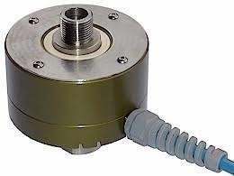
The draw work sensors are used in oil rigs for depth tracking of well. It digitally count the amount of rotational movement as the draw- works drum turns when the drilling line moves up or down. Each count represents a fixed amount of distance traveled, and when tied into a time-based counter, can give either an instantaneous or an average rate of penetration (ROP). The depth is accurately measured by using hook load sensor along with draw work sensors.

Figure: 5.1 Draw work sensor

Hook- Load Sensors
These sensors are used to measure the drilling line tension. The total includes the weight of the crown block, drill string in air, drill collars and ancillary equipment, reduced by any force that tends to reduce the weight. The Hook-Load sensors are also used along with Draw work sensors for accurate measurement of depth.

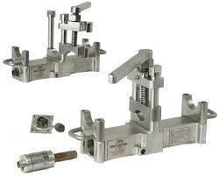

Figure: 5.2 Hook- Load Sensors

Standpipe Pressure Sensors
On most drilling rigs the standpipe manifold has a number of pressure taps where gauges may be installed. The sensors can be installed at a convenient point by removing one of these gauges. Inside the sensor is a sensitive diaphragm that detects variation in pressure and converts these hydraulic pulses to electrical voltage pulses. The voltage output is relayed to the rest of the surface equipment by means of an electric cable.

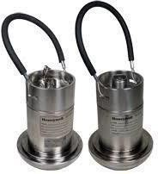
Figure: 5.3 Standpipe Pressure Sensors

Pump Stroke Sensor
Pump Stroke Sensors are a vital part to any drilling rig operation. When a mud pump is in operation, the driller must know how much mud is flowing down hole in order to keep the operation running at peak efficiency. Pump stroke sensors assist the driller by measuring the mud pump’s strokes per minute and total strokes.

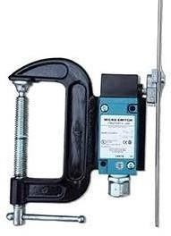
Figure: 5.4 Pump Stroke Sensors

Other type of sensors used in oil rigs are -

Flow-in tracking sensors
Flow-tracking sensors are used to monitor fluid-flow rate being applied downhole as well as the pump strokes required to achieve this flow rate. Data gathered from these sensors are essential inputs to calculating drilling-fluid hydraulics, well control, and cuttings lag and can help identify early signs of kick or loss circulation.

Two commonly used types are proximity and/or whisker switches. A proximity switch, activated either by an electromagnet (coil) or a permanent magnet, acts as a digital relay switch when it incorporates electrical continuity. A whisker switch is a microswitch that is activated only when an external rod (called a whisker) forces a piston to raise a ball bearing to initiate contact against it . Both types are digital counters; an increase in counts will correspond to a specific increase in both flow rate and pump rate.

Pressure-tracking sensors
Pressure-tracking sensors are used mainly to monitor surface pressure being applied downhole. Data gathered is used either to validate calculated values or to confirm potential downhole problems such as washouts, kicks, or loss of circulation.

Two types of sensors are available, and both monitor pressure from a high-pressure diaphragm unit located on either the standpipe or the pump manifold. The first sensor type derives its physical input from mud pressure expanding a rubber (or Viton when high

temperature is involved) diaphragm within the knock-on head. The second sensor is directly connected to the standpipe manifold itself.

Flow-out tracking sensor
Commonly called a “flow paddle,” this sensor measures flow rate coming out of the annulus using a strain-gauge analog transducer .Changes in resistance values are directly related to either an increase or a decrease in mud-flow rate. This sensor provides an early warning of either a kick condition (sudden increase in flow rate) or a loss of circulation (sudden decrease in flow rate).

Drill-monitor sensors
Drill-monitor sensors monitor surface revolutions-per-minute (RPM) values, rotary torque, and hook load. The torque sensor is a clamp that sits around the main power cable to the top-drive system (TDS). It works on the principle of Hall effect. Hence, the amount of torque produced (pipe rotation) is directly measured from the amount of electric current produced. The data can be used to identify formation strength, or downhole sticking problems.
A digital rotary sensor is similar to a proximity sensor used in a pump. It is shaped differently but acts on the same principle.
The hook-load sensor uses the same transducer type as in a pressure-tracking sensor. As the deadline experiences strain, the reservoir has load applied across it, which pressures the hydraulic fluid. This pressure increase is translated to a measurement value. These measurement values are then correlated to potential downhole problems such as kicks or stuck pipe.

Pit-monitor sensor
Most pit-monitor sensors use ultrasonic transit time to measure mud level. The sensor is mounted over the pit above the maximum mud level, and sends a sonic wave that is reflected back to the receiver. The transit-time measurement is then directly transformed to a volume measurement. This critical measurement is actively used to monitor potential kicks (rapid increase in pit volume) or loss of circulation (rapid decrease in pit volume).

Gas-detection sensors
The gas-detection sensors consist mainly of a gas trap, a pneumatic line linking the gas trap to the gas-detection equipment (which is found inside a mud-logging unit), and the gas- detection instruments (chromatograph and total-gas detectors). A gas trap is a rotating agitator, that agitates the mud flowing through it to release gases.
A gas chromatograph takes a sample of gas and separates out some of these components for individual analysis. Typically, methane (C1) through pentane (C5) are the gases of interest.
Most logging companies currently use a flame ionization detector (FID) gas chromatograph and total-gas detector. The FID responds primarily to hydrocarbons and has the widest linear range of any detector in common use. The output signal is linear for a given component when concentrations vary from less than one part per million (ppm) to percent levels. A gas chromatograph takes a sample of gas and separates out some of these components for individual analysis.
Typically, methane (C1) through pentane (C5) are the gases of interest. The gas-detection sensors consist mainly of a gas trap, a pneumatic line linking the gas trap to the gas-detection equipment (which is found inside a mud-logging unit), and the gas- detection instruments (chromatograph and total-gas detectors). A gas trap is a rotating agitator, that agitates the mud flowing through it to release gases.

The total-gas detector samples gas in a manner similar to that of a chromatograph, the only difference being that there is no column in the detector and, hence, no separation of components (i.e., it burns the “total” hydrocarbon gas sample as one).

Directional Sensors
To survey the borehole continuously while drilling requires the use of rugged, solid-state accelerometers and magnetometers. Accelerometers measure components of the Earth's gravitational field, while magnetometers measure components of the Earth's magnetic field. In each case the fields are acting in a specific direction, and by measuring the orientation of the surveying tool with respect to that direction the inclination, azimuth and tool face can be determined.
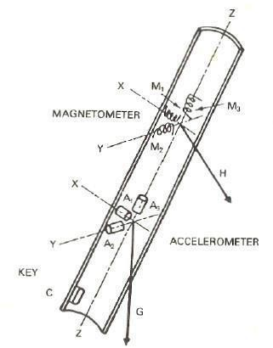

Figure: 6.1 Arrangement of accelerometers and magnetometers

Accelerometers
This sensor is used to measure the earth gravity acceleration. It uses piezo resistive (PR) material. The unique property of this material is that the electrical resistance changes when stress or strain is applied on it. To be used as accelerometer, a mass is put on top of PR material as described in simplified drawing below.

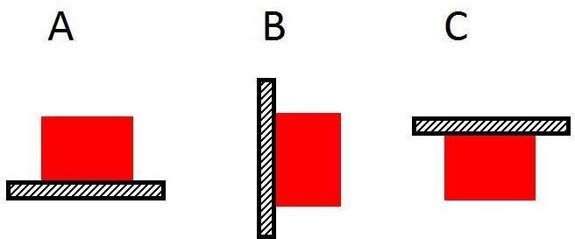

Figure: 6.2 Accelerometers

In vertical position, figure 1a, the red mass is applying pressure to black PR material. In horizontal position, figure 1 b, the mass does not apply any force perpendicular to PR; and in reverse vertical position, figure 1c, the mass is pulling PR material. The above figures represent different tool position along the tool axis. PR material resistance changes as the force changes due to different position. This resistance change is measured by electronic device inside MWD directional package. There are 3 accelerometer sensors inside MWD directional package which are perpendicular to each other. Those sensor measurements are combined to derive tool’s inclination, total gravity force and gravity tool face direction.
As accelerometer relies on the mass force acting on the PR material, it is easily affected by the vibration or sensor – hence MWD tool – movement. When the tool moves or vibrates during the measurement, the force acting to the PR material is changing and causing constant resistant change. This condition leads to false gravity acceleration measurement. The ideal measurement situation is when the tool is in steady condition, no movement nor vibration.

Magnetometers
It is called as fluxgate magnetometer. It uses 2 set of wire coils. The first coil is connected to the alternating current source. As a result, a magnetic field is generated with constantly alternated magnetic polarity. The generated magnetic field induces the second coil, so that the second coil generates induced alternating electric current. In a magnetic-background- free environment, the induced alternating current measured at the second coil can be seen in the figure 6.2 (a).

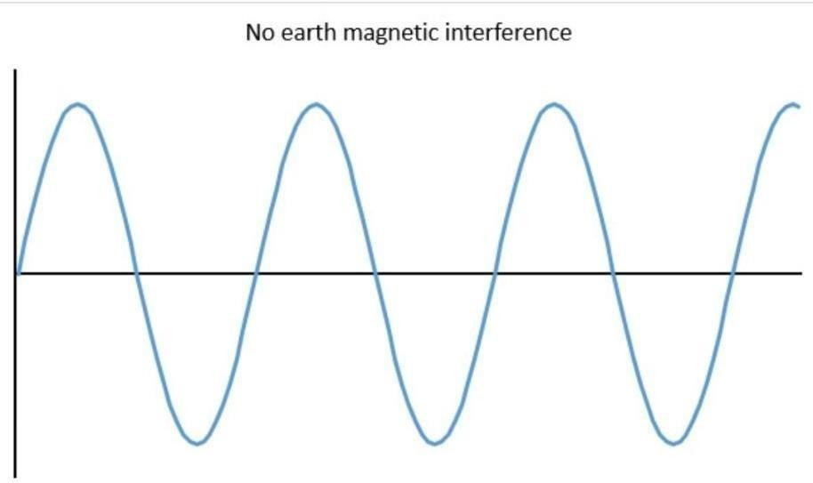
Figure: 6.3 (a) Magnetometer with 2 set of wire coil

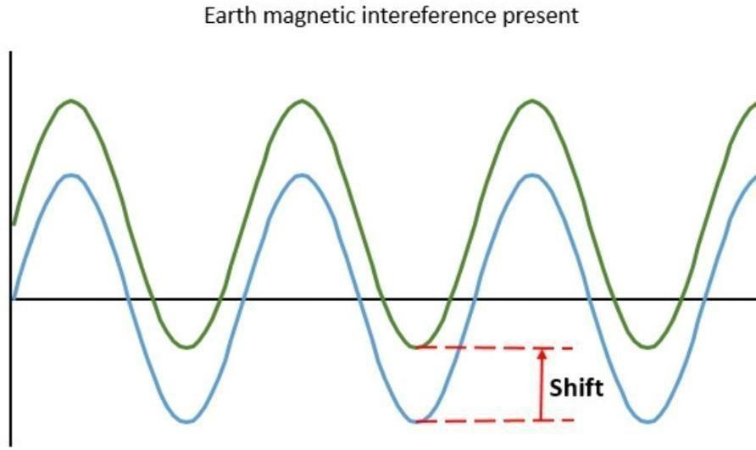
Figure: 6.3 (b) Magnetometer with 2 set of wire coil

When the coils are exposed in a field that has background magnetic field, e.g. earth magnetic field, the alternating current measured at the second coil is shifted (figure 2b). The amount of the shifting depends on the second coil alignment relative to the background magnetic field. Maximum shifting occurs when the coils are parallel to the background magnetic field.

Corrections for sensor reading Magnetic Declination
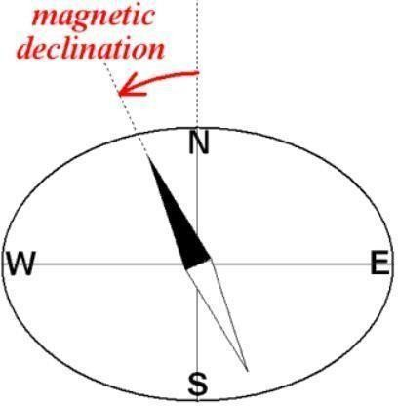
Magnetic declination is the angle on the horizontal plane between Magnetic North and True North. Magnetic declination varies with time and location. Declination values can be obtained from isogonic charts provided by various geophysical institutions across the world. Magnetic declination can be positive or negative depending on the angle between true north and magnetic north. If angle is clockwise declination will be positive otherwise it will be negative.

Figure: 7.1 Magnetic Declination

Grid Convergence

Grid convergence is an angle between grid north and true north. It can be negative or positive depending on the angle between true north and the grid north. If angle is clockwise it will be positive otherwise it will be negative. Grid lines are vertical lines joining the two points of same longitude.

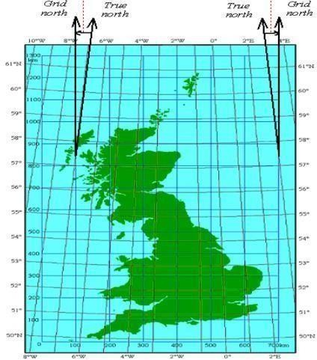

Figure: 7.2 Grid Convergence

Applying Declination and Grid Convergence simultaneously

True Azimuth = Magnetic Azimuth + Declination Grid Azimuth = True Azimuth – Convergence
Grid Azimuth = Magnetic Azimuth + Declination – Convergence

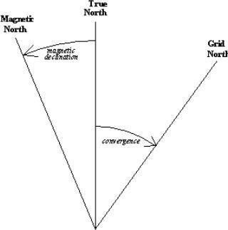
Figure: 7.3 Applying Declination and Grid Convergence

BHA Sagging

Sagging is caused by deflection of BHA tools due to gravity. Sagging occurs in directional wells and is very common and vigorous problem for horizontal wells. Sagging is responsible for misalignment of directional sensors along the borehole direction, which affects the measurement of the sensors. Severity of the error due to sagging mainly depends on type of BHA, geometry, hole size, collar size, sensor placement stabilizer spacing (shorter distance will cause less deflection), material type (stiffer the material lesser will be the deflection ) and some other factors. Inclination difference between true hole inclination and measured hole inclination by MWD tool or it is called as inclination.

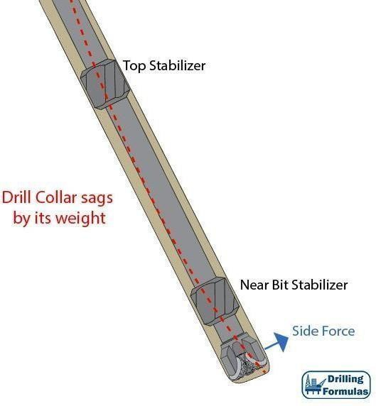

Figure: 7.4 BHA Sagging
- Difference between LWD and MWD

- One basic difference between MWD and LWD is that MWD provides real time data whereas in LWD data is stored in memory while drilling and decoded when the tool reaches the surface.

- There is also the difference in the type of information they record. LWD tools measure formation properties like density, porosity, resistivity, acoustic caliper, gamma ray radioactivity etc whereas MWD can give inclination, azimuth, rotational speed of the drill string, type and severity of the vibration downhole, downhole temperature, torque and weight on bit.

- Once a well angle exceeds 60 degrees, the logging tools can no longer be pushed through the well to retrieve information, making conventional logging tools ineffective. Originally designed MWD to overcome well logging challenges of wells being drilled at extreme angles, MWD is a type of Logging-While-Drilling (LWD) where tools are encompassed in a single module in the steering tool of the drill string, at the end of the drilling apparatus (or the bottom hole assembly).

- Providing wellbore position, drill bit information and directional data, as well as real- time drilling information, MWD uses gyroscopes, magnetometers and accelerometers to determine borehole inclination and azimuth during the actual drilling. The data is then transmitted to the surface through pulses through the mud column (mud pulse) and electromagnetic telemetry. Decoded at the surface, the data can also be transmitted to an offsite location immediately.

Drill String Magnetic Interference

Introduction: Magnetic interference can be defined as the corruption of geomagnetic field by a field from an external source. It can cause disruption in obtaining proper survey readings mainly azimuth; from the magnetic sensors.

Causes of Error:

Drill String / BHA
The drill string can be compared to a long slender magnet with its lower end comprising one of the magnetic poles. It can be magnetized by earth’s magnetic field, that can contribute to calculation error in magnetometer data. Hence, non-magnetic drill collars are used to position the compass or direction sensors out of the magnetic influence of the drill string.

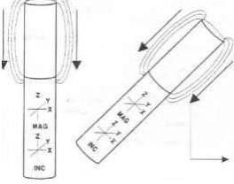
The magnetometers measure the resultant magnetic field of earth and drill strings. The magnetization of drill strings effects the z- axis (tool face) reading of magnetometer only. The extent of error depends on :
-Strength of polarization of drill strings
-Distance of such components from the MWD. This results in a total magnetic field greater than that of earth itself.

Figure. 8.1 Drill String Magnetic Interference

Hole Angle:
When drill string magnetism is causing an error on the Z-axis of magnetometer, only the horizontal component of that error can interfere with the measurement of the Earth's magnetic field. The horizontal component of the Z-axis error is equal to the Z-axis error multiplied by the sine of the hole deviation. This is why the magnetic survey accuracy usually worsens as the hole angle increases.

Hole Direction:
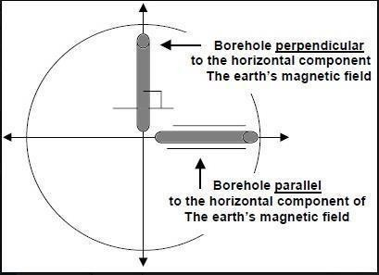
Drilling North-South reduces whereas, drilling East-West increases magnetic interference from the drill string. Because the east / west direction is roughly parallel to the horizontal component, the influence of the field pulling in the direction of Magnetic North is greatly reduced. As the horizontal component of the magnetic field decreases in strength, magnetic force from the BHA becomes a larger portion of the total magnetic field strength.

Figure: 8.2.Hole Direction

Hot Spots
Non-Magnetic Drill Collars and other steel components may develop local areas where the magnetic field strength is greater than normal, called as 'Hot Spots'. It may be possibly due to bending or any other stresses. The hot spot may be further intensified by circulation of mud across steel components.
Before running NMDC in the hole, Hot Spots can be found by running a compass along the outside of the collar or pulling the compass through the inside by a string. If a hot spot is present, the needle will swing, indicating magnetism.

Fish or Casings
Steel components left in hole can be a source of magnetic interference. Since the drill string passes through the set casing, the magnetometers must be drilled far enough beyond the casing to ensure that surveys are not influenced by magnetic interference. Well must also be drilled at a suitable distance from a cased well, so as to avoid interference.

Wellbore Survey Parameters

Inclination: The inclination of the wellbore is the angle in degrees that the wellbore is deviated from the vertical. The vertical line is always parallel to the direction of earth’s gravity. By industry standard, 0 degree inclination is vertical (downward pointing) and 90 degree inclination is horizontal. An inclination angle greater than 90 degrees coincides with the term drilling line.

Azimuth: The angle between the vertical projection of a line of interest onto a horizontal surface and true north or magnetic north measured in a horizontal plane, typically measured clockwise from north. The azimuth is usually quoted in degrees from 0 to 359.

For directional survey, there are three azimuthal reference systems:
- True North: This is the direction of geographic North Pole. The direction is shown on maps by meridians of longitude.
- Magnetic North: This is the direction of horizontal component of Earth’s Magnetic Field lines, at a particular point on Earth’s surface. The positive pole of a magnetic compass aligns itself to the Magnetic North.
- Grid North: Within the UTM (and such) systems, the Earth surface is divided into 60 zones of 6 degrees of latitude. Each grid system has its own central meridian, which defines the direction of Grid North. Only if the Grid meridian lies on actual central meridian, the Grid North overlaps the True North.
- Angle of Dip: In directional well, the effective dip angle is the angle at which the bit strikes the bedding planes. When the effective dip angle is less than 45 degree, the direction of the deviation force is up dip. When the effective dip angle is greater than 45 degree, the direction of the deviation force is down dip.
- True Dip: True dip is the maximum angle that a bedding plane, fault plane or geological surface declines away from a horizontal plane measured in a vertical plane that is perpendicular to the strike of the structure. Any measurement obtained at an angle not perpendicular to strike will yield an apparent dip, which is always less than the maximum angle of declination that is obtained when measuring perpendicular to formation strike.
- Angle of Declination: It is the angle on the horizontal plane between Magnetic North and True North. The angle of Magnetic Declination can be clockwise or counter clockwise from True North to Magnetic North.
- Angle of Convergence: It is the angle between True North and Grid North. The angle can be clockwise or counter clockwise from True North to Grid North.

Bit Selection
The following methods can be used to select the most appropriate bit type for a particular formation: (a) cost per foot; (b) specific energy; (c) bit dullness; and (d) offset well bit records and geological information.

Cost per foot

The criterion for bit selection is normally based on cost per foot, C, which is determined by use of the following equation:
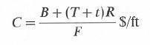

where B = bit cost ($); T = trip time (h); t = rotating time (h);R =rig cost per hour ($/h); and F, length of section drilled (ft).

Cost per foot for a drilling bit is controlled by five variables, and for a given bit cost, B, and hole section, F, cost/ft will be highly sensitive to changes in rig cost per hour, R, trip time, T, and rotating time, t. The trip time may not always be easy to determine unless a straight running in (RIH) and pulling out (POH) of hole is made. In this case, T is the sum of RIH and POH times. If the bit is pulled out for some reason, say to casing shoe for a wiper trip, such duration, if added, will influence the total trip time and, in turn, cost/ft. Bit performance, therefore, can be changed by some arbitrary factor. Rotation time is straightforward and is directly proportional to cost/ft, assuming that other variables remain constant.

The rig cost, R, will greatly influence the value of cost/ft. For a given hole section in a field that is drilled by different rigs, having different values of R, the same bit will produce different values of cost/ft, assuming that the same rotating hours are used in all rigs. The value of cost/ft in this case is not a real value and does not relate to actual or planned expenditure.
The criterion for selection of bits on the basis of cost/ft is to choose the bit that consistently produces the lowest value of C in a given formation or hole section.

Specific Energy
The specific energy method provides a simple and practical method for the selection of drill bits. Specific energy, SE, may be defined as the energy required to remove a unit volume of rock and may have any set of consistent units. The specific energy equation can be derived by considering the mechanical energy, E expended at the bit in one minute. The specific energy equation for a drilling bit is
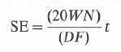

It was concluded that SE is not a fundamental intrinsic property of rock. It is highly dependent on type and design of bit. This means that, for a formation of a given strength, a soft formation bit will produce an entirely different value of SE from that produced by a hard formation bit. This property of SE, therefore, affords accurate means for selection of appropriate bit type. The bit that gives the lowest value of SE in a given section is the most economical bit.

The equation also shows that, for a given bit type in a formation of constant strength, SE can be considered constant under any combination of WN values. This is because changes in WN usually lead to increased values of PR (under optimum hydraulics) and this maintains the balance of the equation. The penetration rate is, however, highly influenced by changes in WN, and for a particular bit type an infinite number of PR values exist for all possible

combinations of WN values. It follows that specific energy is a direct measure of bit performance in a particular formation and provides an indication of the interaction between bit and rock. The fact that SE, when compared with the penetration rate, is less sensitive to changes in WN makes it a practical tool for bit selection.

Bit Dullness

The degree of dullness can be used as a guide for selecting a particular bit. Bits that wear too quickly are obviously less efficient and have to be pulled out of the hole more frequently, which increases total drilling cost. Bit dullness is described by tooth wear and bearing condition.

Tooth wear is reported as the total height remaining and is given a code from T1 to T8. T1 indicates that 1/8 of the tooth height has gone; T4 indicates that 1/2 of the tooth height has gone. Similarly, bearing life is described by eight codes, from B1 to B8. The number B8 indicates that the bearing life has gone or the bearing is locked. A bit that shows high tooth wear and low bearing life is, therefore, not suitable for the particular formation selected. If such a bit were a 1-1-1 type, then the use of a bit with a higher numerical code could reduce wear and bearing deterioration. A bit type 1-2-4may be chosen; the code 2 is selected for the high rock strength, reducing tooth wear, and the code 4 is for a sealed bearing. Code 1 indicates that the bit is a milled tooth type.
IADC dull grading reviews four general bit wear categories:
- Cutting structure (T)
- Bearings and seals (B)
- Gauge (G) Remarks.
These and their subcategories are outlined in the figure.

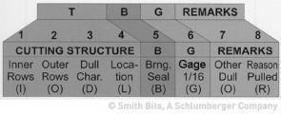
FIGURE. 11.1 .IADC dull grading categories

Cutting structure wear grading (T)

For dull grading purposes, cutting structures are subdivided into four subcategories: inner rows, outer rows, major dull characteristic of the cutting structure, and location on bit face where the major dull characteristic occurs.
Roller Cone Cutting Structure Evaluation. Dull grading begins with evaluation of wear on the inner rows of inserts/teeth (i.e., with the cutting elements not touching the wall of the hole bore). Grading involves measurement of combined inner row structure reduction caused by loss, wear, and/or breakage with the measurement method described above. Outer rows of inserts/teeth are those that touch the wall of the hole bore. Grading involves measurement of combined outer row teeth/insert structure reduction caused by loss, wear, and/or breakage with the measurement method described above.

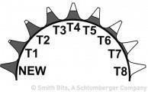

Figure: 11.2 Tooth height measurement

Roller-Cone Cutter or Insert/Tooth Wear Measurement. Measurement of roller-cone cutting structure condition requires evaluation of bit tooth/insert wear status. Wear is reported by use of an eight increment wear scale in which no wear is represented by “0” and completely worn (100%) is represented by “8”.
PDC Bit Cutter Wear Evaluation. Cutter wear is graded with a 0 to 8 scale in which 0 represents no wear and 8 indicates that no usable cutting surface remains PDC cutter wear is measured across the diamond table, regardless of the cutter shape, size, type, or exposure. The location of cutter wear is categorized as either the inner two-thirds or outer third of the bit radius.
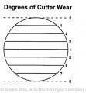
Figure: 11.3. Cutter wear convention (zero is no wear)

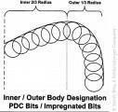

Figure: 11.4 Inner/outer body designation for PDC

PDC Bit Inner and Outer Row Cutter Wear Measurement. For both PDC and surface-set diamond bits, a value is given to cutter wear with the method described above. To obtain average wear for the inner rows of cutters depicted in, the six included cutters must be individually graded, summed as a group, and averaged to obtain the inner row wear grade, (a + b + c + d + e + f) / 6 . This analysis is repeated for each blade, and blade results are summed and averaged for the final result. A similar analysis is made for the seven cutters used in the outer bit rows, and the two results are recorded in the first two spaces of the dull grading form.

Dull Characteristic (D). The cutting structure dull characteristic is the observed characteristic most likely to limit further use of the bit in the intended application. A two- letter code is used to indicate the major dull characteristics of the cutting structure.
The primary cutter dull characteristic, the third cutting structure subcategory, is recorded in the third space on the dull grading record. (Note that noncutting structure or “other” dull characteristics that a bit might exhibit are noted in the seventh grading category.) Category 3 defines only primary cutter wear, whereas Category 7 can be used to describe either secondary cutting structure wear or wear characteristics that relate to the bit as a whole and are unrelated to cutting structure. Grading codes for the other dull characteristics category are the same as those listed above.

Roller-Cone Bit Dull Location (L). A two-letter code is used to indicate the location of the wear or failure that necessitated removal of the bit from service.

PDC Bit Cutting Structure Drill Location. The last of the cutting structure-related wear grades, dull location, indicates the location of the primary dull characteristic. Possible locations include the cone (C), nose (N), taper (T), shoulder (S), gauge (G), all areas (A), middle row (M), and heel row (H). Location grades are reported in the fourth space on the dull grading form.

Bearing and seal (B) criteria (not used for PDC bits)
IADC provides secret protocols for estimation of bearing and seal wear in non-sealed and sealed bearing assemblies. Seal and bearing grading apply only to roller-cone bits. It is always marked “X” for PDC bits.

- Estimating Wear on Non sealed Bearings. For non-sealed bearings, wear is estimated on a linear scale of 0 to 8: 0 is new, 8 is 100% expended.
- Estimating Wear on Sealed Bearings. A checklist for the seal and bearing system condition is provided.
- If no seal problems are encountered, use the grading code E.

- If any component in the assembly has failed, use the grading code F.

- If any portion of the bearing is exposed or missing, it is considered an ineffective assembly; again, use the grading code F.
- Use the grading code N if it is not possible to determine the condition of both the seal and the bearing.
- Grade each seal and bearing assembly secretly by cone number. If grading all assemblies as one, report the worst case.

Gauge grading (G)
The gauge category of the Dull Bit Grading System is used to report an under gauge condition for cutting elements intended to touch the wall of the hole bore. For diamond and PDC bits only, gauge is measured with an API-specified ring gauge. (API specifications for ring gauges for roller-cone bits have not been issued.

Roller-Cone Bit Gauge Grading. For three-cone bits, the “two-thirds rule” is applied to measuring the gauge condition. The amount out of gauge, as measured by the ring gauge, is multiplied by two- thirds to give the true gauge condition. For two-cone bits, gauge is the measured distance from either the gauge or heel elements, whichever is closer to gauge.

Measurements are taken at either the gauge or heel cutting elements, whichever is closer to gauge. Under gauge increments of 1/16 in. are reported. If a bit is 1/16 in. under gauge, the gauge report is 1. If a bit is 1/8 in. (2/16 in.) under gauge, the gauge report is 2. If, a bit is 3
∕16 in. under gauge, the gauge report is 3, and so forth. Round to the nearest 1 ∕16 in. Gauge rules apply to cutting structure elements only.

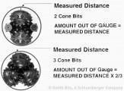

Figure 11.5 Measuring out of gauge

PDC Bit Gauge Grading. For diamond and PDC bits, gauge is measured with a nominal ring gauge.

Use of an “IN” code indicates that the bit remains in gauge. Under gauge increments of ∕161 in. are reported. If a bit is 1 ∕16 in. undergauge, the gauge report is 1. If a bit is 1 ∕8 in. (2∕16 in.) undergauge, the gauge report is 2, and so forth. Round to nearest 1 ∕16 in. Gauge rules apply to cutting structure elements only. Measurements are taken at the gauge cutting elements.

Roller cone and PDC bit remarks
The “remarks” category allows explanation of dull characteristics that do not correctly fit into other.
categories and is the category in which the reason a bit was removed from service is recorded.

Roller-Cone Bit Other Dull Characteristics (O). Dull characteristics can be used to report dull characteristics other than those reported under cutting structure dull characteristics (D). Evidence of secondary bit wear is reported in the seventh grading category. Such evidence could relate to cutting structure wear, as recorded in the third space, or may report identifiable wear, such as erosion, for the bit as a whole. The secondary dull characteristic often identifies the cause of the dull characteristic noted in the third space.
Roller-Cone and PDC Bit Reason Pulled (R). The eighth dull grading category reports the reason why a bit was pulled.

Well bit records and geological information
Drilling data from offset wells and geological information can provide useful guides for the selection of drill bits. Roller-Cone Bit Other Dull Characteristics (O). Dull characteristics can be used to report dull characteristics other than those reported under cutting structure dull characteristics (D). Evidence of secondary bit wear is reported in the seventh grading category. Such evidence could relate to cutting structure wear, as recorded in the third space, or may report identifiable wear, such as erosion, for the bit as a whole. The secondary dull characteristic often identifies the cause of the dull characteristic noted in the third space. Sonic logs from such wells can also be used to provide an estimate of rock strength, which, in turn, provides a guide for selecting the proper bit type.

12. NMDC Spacing

For sensible magnetic azimuth measurement, the magnetic effect of the drill string has to be reduced by the insertion of non-magnetic drill collars (NMDC) into the drill string. NMDC can only reduce the effect of magnetic interference from the drill string – they do not remove it completely. An acceptable azimuth error of 0.25° was chosen as the limit for ‘Good Magnetic’. It should be noted that more recent work has suggested that magnetic interference azimuth error is likely to be of the order of 0.25 + 0.6 x sin (Inc) x sin(azimuth).
So, basically there are two problems:
  - How many NMDC are required in the BHA?

The number of NMDC required depends on various factors:

    - The horizontal component of the earth's magnetic field.
    - The inclination and the azimuth of the well.
The number of NMDC required on a well with a given inclination and azimuth varies considerably according to position on the earth's surface.
  - Positioning of the sensors within the nonmagnetic section?
The spacing of the magnetic sensor is given as a percentage of the total length of NMDC in the BHA. By making assumptions about the magnetic poles in the steel above and below the NMDC, the expected optimum compass spacing to minimize azimuth error and the magnitude of the expected azimuth error can be calculated.

Pole Strength
Field measurements by Shell have been made of pole strengths for typical Bottom Hole Assemblies. These values are for North Sea area in Northern Hemisphere; these should be reversed for Southern Hemisphere.

Upper Pole Lower Pole
Drill collars up to + 900 μWb. Stabilizers and bit up to -90 μWb. 10m drill collar below NMDC up to -300 μWb
Turbines up to -1000, μWb

Azimuth Error
Drill string magnetization affects the observed horizontal component of the local magnetic field. The compass error increases with inclination and with increased easterly or westerly azimuth of the wellbore.

NMDC Length Selection Charts
Using the formulae from SPE 11382 by S.J. Grindrod and C.J.M. Wolff, NMDC charts can be constructed for various well inclinations and azimuths and for a maximum acceptable azimuth error i.e. 0.25°.By varying the dip and B for local conditions, charts can be prepared for various areas of the world.
The charts can be used in two ways.
- To estimate the recommended length of NMDC for a particular situation.
If a different length was used, an estimate of the possible azimuth error can be obtained.

Rules of Thumb for Magnetic Sensor Spacing
- Consider how much steel there is below the NMDC. Steel <9"section - minimum
9 to 20" - intermediate case Steel >20"–maximum

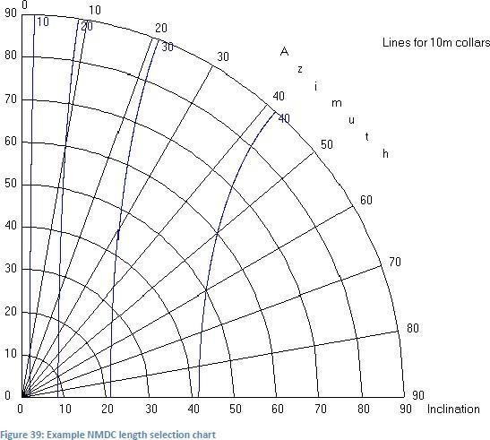

Figure: 12 .1 NMDC Length Selection Charts

If minimum steel is used below NMDC (bit + stabilizer)…….spacing at 33% approx. If intermediate is used below NMDC (bit + mud motor) spacing at 40% to 45%
If maximum steel is used below NMDC (bit + mud motor) spacing at 45% to 50%.

- Do not position the magnetometers within 3" of any tool joints.
- Do not position the magnetometers within 5" of a non-magnetic stabilizer.

Typical Configurations
Vertical Wells
  - one NMDC for magnetic single shots or multi-shots or:
  - one NMDC above MWD when it is run

Deviated Wells
  - low angle (< 15° inclination):
  - 8ft NM (pony) DC below MWD plus 1 NMDC above MW
  - moderate and high angle (16° - 60° inclination) with mud motor
  - one NMDC below MWD plus 2 NMDC above MWD
  - moderate and high angle (16° - 60° inclination) without mud motor.

Equivalent Circulation Density (ECD)
Monitoring annular pressure while drilling is one of important subjects to avoid drilling problems, such as pack off, formation fracture and hole cleaning issues. Measurement while drilling (MWD) tool offers this monitoring service using pressure sensor mounted on the collar wall.

Annular Pressure (AP)
Annular pressure is created by hydrostatic pressure of mud column along the wellbore. There are 2 types of annular pressure:

Static annular pressure
is created by hydraulic pressure of mud plus cuttings suspended in the mud when there is no flow in the annulus, hence it is called static.

Dynamic annular pressure
Is static annular pressure plus pressure drop along the annulus of well bore. This pressure drop is created by the friction force between mud particles and wellbore and pipes due to mud flowing in the annulus.

To measure AP, MWD tool is equipped with pressure sensor mounted on the collar, pointing toward to the annulus. This sensor is able to record both static and dynamic pressure. Data collected by the sensor is then transmitted to surface and stored into internal tool’s memory.

Equivalent Circulating Density (ECD)
Annular pressure is normally expressed as equivalent circulating density by using the following equation:
ECD = AP / (0.052 * TVD)

Where ECD is in ppg; AP is in psi and TVD is in ft.
The AP value is taken directly from the transmitted measured data by the pressure sensor. The TVD is the vertical depth between the pressure sensor depth and the point where the

mud is exposed to atmospheric pressure, which can be flow line in the flow-line-quipped rig or mean se level when the rig is riser less.

Annular Pressure Application

ECD is a dynamic value which depend on wellbore conditions. It can increase or decrease, so that the ECD can be used to understand the wellbore condition.

Formation Integrity Test (FIT) or Leak Off Test (LOT)
During FIT or LOT, battery powers the sensor to record the data and real time data is transmitted to the surface. Only the highest and the lowest pressure data are transmitted. The complete pressure data can be retrieved from tool’s internal memory when the tool reach surface. This data is used to analyzed the formation strength beneath casing shoe.

Mud weight adjustment
The ECD is calculated continuously as the annular pressure from tool’s pressure sensor is received at the surface. The mud weight is then adjusted according to the calculated ECD to have a balance with formation’s fracture gradient and formation pressure.

Hole cleaning
One of the function of drilling mud is to transport cuttings to surface. The wellbore must be clean to avoid drilling problems such as torque increase or even pack off.
If transportation of cuttings is ineffective, EMW can increase due to accumulation. In this case:
  - A high viscosity mud can be pumped to sweep the cuttings
  - Mud flow rate can be increased
  - A wiper trip should be made

Mud gel strength breaking force

During make up drill pipe stand connection before continue drilling, the mud pumps are stopped. During this static state, the mud becomes gel to suspend the cuttings. After

connection of drill pipe stand has been made, the pumps are brought back to operation and the mud starts to flow again.
During FIT or LOT, battery powers the sensor to record the data and real time data is transmitted to the surface. Only the highest and the lowest pressure data are transmitted. The complete pressure data can be retrieved from tool’s internal memory when the tool reach surface. This data is used to analyzed the formation strength beneath casing shoe.
This is critical when the ECD safety margin is very tight, since there is a possibility to fracture the formation especially beneath the casing shoe as it is considered as the weakest point. During FIT or LOT, battery powers the sensor to record the data and real time data is transmitted to the surface.
Only the highest and the lowest pressure data are transmitted. The complete pressure data can be retrieved from tool’s internal memory when the tool reach surface. This data is used to analyzed the formation strength beneath casing shoe.
During FIT or LOT, battery powers the sensor to record the data and real time data is transmitted to the surface. Only the highest and the lowest pressure data are transmitted. The complete pressure data can be retrieved from tool’s internal memory when the tool reach surface. This data is used to analyzed the formation strength beneath casing shoe. To measure AP, MWD tool is equipped with pressure sensor mounted on the collar, pointing toward to the annulus. This sensor is able to record both static and dynamic pressure. Data collected by the sensor is then transmitted to surface and stored into internal tool’s memory.

Drill string Vibrations

Downhole vibrations are separated into three primary classifications, axial, torsional and lateral/transverse. These three vibration modes have different vibrational patterns, are generated by different sources and lead to different problems with varying severity. Combinations and interactions of these motions can exist, increasing the complexity of the vibration motion. At low level, the vibrations are harmless. However, in severe cases, drill string vibrations caused by one or a combination of these modes can have catastrophic consequences.

Axial vibration

This mode of vibration generates vibrations in the direction along the axis of the drill string, i.e. in the wellbore direction. Axial vibrations are caused by the movement of the drill string, upwards and downwards, and may induce bit bounce. Bit bounce is seen when large weight on bit (WOB) fluctuations causes the bit to repeatedly lift off bottom, in vertical direction along the drill string, and then drop and impact the formation.
Axial vibrations are damped by the drill string itself due to the stiffness in the length direction and can be directly detected by the driller at shallow depths, as the vibrations travels to surface through the drill string. This mode of vibration is considered less aggressive than the other modes and the recorded axial accelerations are usually significantly lower, due to the large masses that have to be set in motion.
Real-time mitigation actions include adjusting the revolutions per minute (RPM) and WOB, by increasing the WOB and reducing the RPM, to change the drill string energy. If this does not work, it is recommended to stop drilling to allow the vibrations to cease and thereafter start drilling with different parameters.

Torsional vibrations

Torsional vibrations are seen as twisting motions in the drill string and the main mechanism for the creation of torsional vibrations is stick-slip. The vibrations are generated when the bit and drill string is periodically accelerated or decelerated, due to

frictional torque on the bit and BHA. Torsional vibrations lead to irregular downhole rotations.
The severity of stick-slip will affect how long the bit stays stationary and consequently the rotational acceleration speed when the bit breaks free.

The drill string is continuously experiencing some torsional vibrations, as the bit and drill string are subjected to friction. Torsional vibrations are damped by the torsional stiffness of the drill string and by the friction against the wellbore wall. The stiffness in torsional direction is not as significant as the stiffness in the length direction and hence the dampening is less pronounced than for axial vibrations. The vibration mode is observed at surface as large variations in torque values. Even in deviated wells, torsional vibrations can be detected by surface measurements and reduced by the driller. During drilling, the stick-slip level can be reduced by lowering the WOB and increasing the RPM.

Lateral vibrations

Lateral vibrations are seen as side-to-side motion in transverse direction relative to the string. The vibration mode is primarily generated by whirl. In severe cases it is known for triggering both axial and torsional vibrations, a phenomenon called mode coupling.
Transverse vibrations are viewed by the industry as the most destructive mode, entailing severe damage to the BHA components and wellbore, as the bit and BHA continuously impact the wellbore. The interaction between the bit/BHA with the wellbore wall leads to problems such as; over gauge holes, damaged equipment, lack of well direction control and drill string fatigue.
The dampening of lateral vibrations is weak and caused by internal friction and surrounding drilling fluid. Transverse vibrations are not easily detected at surface, as the vibrations tend to dampen out, upwards along the string. The RPM is often reduced, while the WOB is incr eased. If the vibrations continue, the assembly is picked off bottom, allowing the torque to unwind and the drilling restarts with different drilling parameters

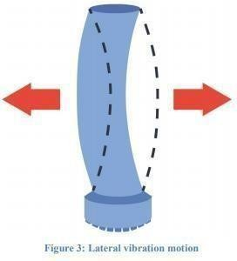
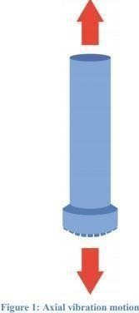 Figure 13.1 Axial Vibration
Figure 13.2.Lateral Vibration

The vibration mode is primarily generated by whirl. In severe cases it is known for triggering both axial and torsional vibrations, a phenomenon called mode coupling.
TABLE 13.1 Vibration mitigation

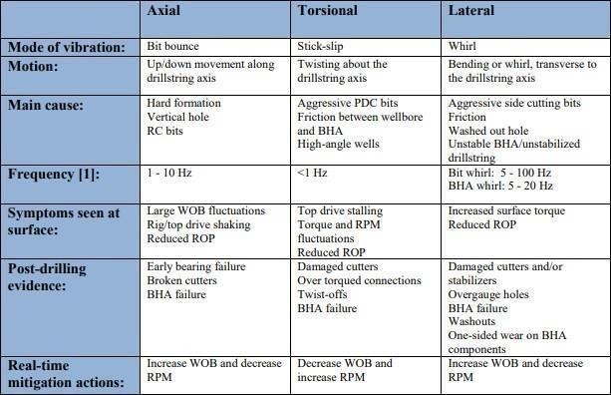

Sources of drill string vibration

Drill string vibrations are mainly caused by the bit and drill string interactions with the formation under specific drilling conditions. Sources can excite downhole vibrations directly, trigger other vibration mechanisms or induce resonance into the drill string. Resonance is generated if the excitation source frequency is close to the natural frequency of the drill string (axial, torsional or lateral). Large-amplitude vibrations during drilling will lead to accelerated drill string fatigue.

Mass imbalance: A rotating drill string is characterized as unbalanced when the center of gravity does not coincide with the axis of rotation. Centrifugal forces are generated when the unbalanced drill string is rotated, leading to noticeable levels of

vibration. Although it is evident that mass imbalance is a source of vibrations, it is often assumed that the bit is the main generating source.

Hole size and hole angle

The borehole size relative to the outer diameter (OD) of the BHA determines the amount of deflection the tools undergo when vibration is generated. Over gauge holes enables side-to-side movement and buckling. The bit/BHA “walks” around the hole freely, touching the wellbore wall and thereby generates whirl and transverse vibrations. The drill string lacks sufficient stabilization. In contrast, under gauge sections may amplify the stick-slip tendencies, due to increased torque and friction factor.

BHA component failure is more likely to occur in vertical holes, as vertical and near vertical wells increase the likelihood of experiencing severe axial and lateral vibrations. The WOB in vertical wells will have a larger influence and bit bounce may become a problem. In directional and highly deviated wells, gravity tends to reduce the potential of sideways motion of the rotating assembly, as it is pushed towards the low side of the wellbore. The side forces on the BHA are more pronounced. If the well inclination increases above 15 degrees, the string at the BHA is less likely to helically buckle, due to the increase in normal force that must be overcome. Torsional vibrations on the other hand, are more probable to occur in deviated holes, being excited by the frictional torque.

Drilling parameters (RPM, WOB and mud lubricity):
Vibration control can be performed during drilling by manipulating the RPM, WOB, flowrate and mud lubricity. Parameters that should be manipulated without negatively impacting the drilling performance. As vibrations are a function of RPM and WOB, wrong combination will lead to high vibration tendencies. Defining a perfect range for these drilling parameters is essential in order to reduce the level of vibration and improve the drilling performance. Defining this range can be done in the pre-drilling phase by using BHA design optimization software or during drilling by monitoring real- time data.
When stick-slip is generated, due to the BHA rubbing against the wellbore wall, the mud lubricity can be increased to reduce the friction at the bit and BHA. The mud lubricity properties are frequently altered to obtain vibration resistant conditions.

Bit selection

Drilling efficiency and vibration generation is dependent on choosing the correct bit for the formation to be drilled. Bit induced vibrations are generated when the bit design and functionality are inadequate for the specific operation. PDC bits normally generate higher level of torsional vibrations, due to their high friction, while RC bits increases the likelihood of experiencing axial vibrations. The bit should therefore be preselected based on formation type.

Formation type

Vibrations are affected by the hardness of the formation and increasing formation strength is normally associated with increased vibration level [6]. However, it is important to keep in mind that also soft formations can lead to high vibration levels. Washouts and unstable formations enable the drill string to move sideways more freely, increasing the likelihood of experiencing lateral vibrations and whirl.

Differential hardness of rocks, such as interbedded sands and clays or limestone stringers, creates uneven drilling and acts as a source of vibration. Severe shock and vibration are associated with interbedded formations that have sections with high- compressive strength and low-compressive strength, due to varying drill ability.

BHA design
Poor pre-planning of the BHA design and configuration can lead to severe shock and vibration. Critical components such as bit, reamers and stabilizers must be reviewed in terms of functionality and interaction with the surroundings, to provide a vibration limiting BHA. Placement of these components and small changes made to the design can lead to large enhancements, in terms of lower vibration level and improved cost effectiveness. In addition, various tools can be added to the assembly to prevent severe vibrations from occurring.
Drill string vibrations have several damaging consequences contributing to poor drilling performance, which leads to non-productive time (NPT) and additional expenditure. Prominent vibrations can also lead to wellbore instability and damaged downhole components.

The most obvious consequences of drill string vibrations on downhole tools are:
- Bit and reamer damage, reducing the ROP and increasing bit/reamer costs.
- Motor and rotary steerable damage, causing unplanned trips.
- Accelerated fatigue of all drill string components, consequently leading to twist- offs.
- Potentially fishing trips. In worst case, unplanned sidetracks around stuck assemblies, destruction of downhole electronics, causing failure of tools and additional trips.
- Interference with downhole tool telemetry, causing gaps in data.
- Damaged rig equipment, causing NPT and increased costs.

Lost Circulation Tools
Lost Circulation of circulation is the uncontrolled flow of whole mud into ahigh- permeability zones, cavernous formations and natural or induced fractures during the drilling or completion of a well.

Effects of Lost-circulation on MWD

Mud pulse telemetry is the most widely used data transmission system. In this system circulating mud is used as a medium to transmit the data from the downhole to the surface receiver. For this transmission we require incompressible, continuous flow of the mud from sub-surface to surface.
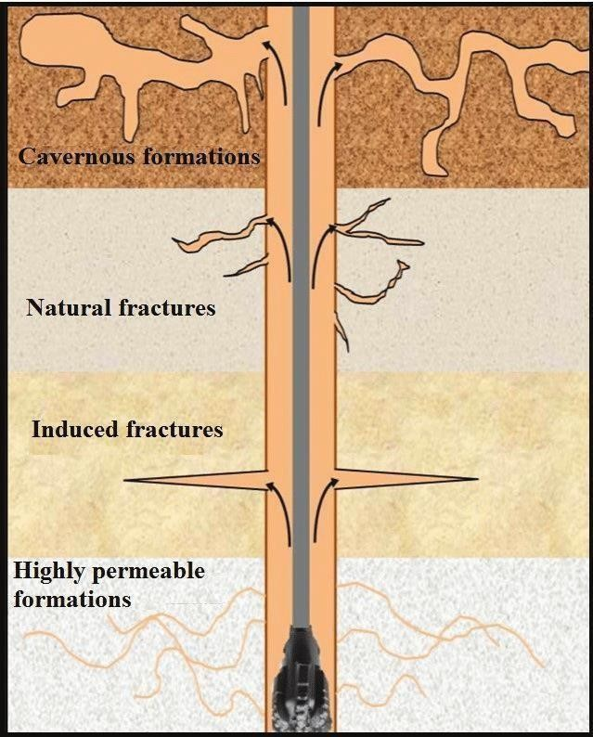
If lost circulation will occur at sub-surface, data transmission will be affected badly. Receiver at surface will not be able to receive complete data and even the data strength will be weak which will make it difficult for interpretation.
So obtain the quality data lost circulation should be prevented. Complete prevention of lost circulation is not possible. To prevent lost circulation of the mud following precautions and steps are required. To prevent lost circulation of the mud following precautions and steps are required-

Figure: 14.1 Lost-circulation on MWD

- Proper estimation of pore pressure and fracture gradient.
- Minimize ECD.
- Avoid restrictions in annulus.
- Use of proper mud weight, it should not exceed the fracture gradient.
- Proper hole cleaning.
- Setting casing to protect weak formation zones.
- Identify transition zones

Some common lost circulation materials are: calcium carbonates, crushed mica, cellulosic plant particles, graphite and dolomites. Polymers can also be used as lost circulation material. If lost circulation will occur at sub-surface, data transmission will be affected badly. Receiver at surface will not be able to receive complete data and even the data strength will be weak which will make it difficult for interpretation.

Commonly used Tools for lost circulation identification
- Spinner Surveying too
- Radioactive Survey
- Temperature Logging

Drill string Vibration Standards and Measurement Techniques

Standardization
As to date, there is no standard present on how to handle and measure vibrations. Each directional supplier has their own internal procedures. Prevention actions must be given adequate attention in the pre-drilling phase and evaluated sufficiently after ended operation. To perform proper mitigation, an extensive process of planning, conducting and evaluating is needed.

- Proper training and communication of key personnel are a must.

- All personnel must be familiar with the different modes of vibrations and possible causes.

- Standard guidelines should exist to prevent these causes, and effective mitigation procedures should be established.

- Acceptable level of vibrations and justifiable drilling parameters must be identified for the specific operation.

- Prevention actions must be given adequate attention in the pre-drilling phase and evaluated sufficiently after ended operation.

- Logs, information on runs with high level of vibration, information on successful runs, mitigation procedures and failure reports should be easily accessible for all involved.

Suggestion to vibration mitigation workflow

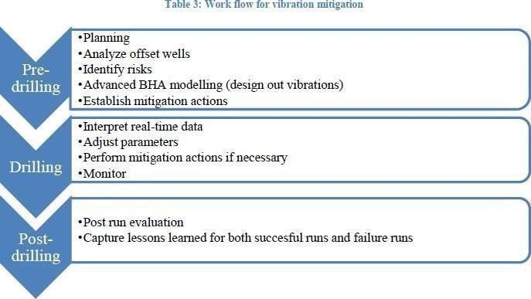
Figure.14.1 Suggestion to vibration mitigation workflow
Different measurement approaches
Today the use of vibration measurement tools has become a standard procedure and most operators have integrated vibration sensors run together with the MWD and logging while drilling (LWD) applications. The following figure explains a basic approach in utilizing MWD tools to measure and classify the vibrations. As shown in the Figure, ax, ay and az are, respectively, defined as survey signal of triaxial accelerometers on the xyz axis; then the resultant acceleration is defined as. The sensors measurement frequency is 100 Hz. We used 𝐴 = (𝑎𝑥2 + 𝑎𝑦²)½ to express the lateral vibration of the drilling bit and used az to express the longitudinal vibration of the drilling bit.

For most formation data acquisition, standards are present to make it easy to compare and optimize the operation. The vibrations are most often measured by an accelerometer mounted in the MWD [2]. 1g = 9.8 m/s2

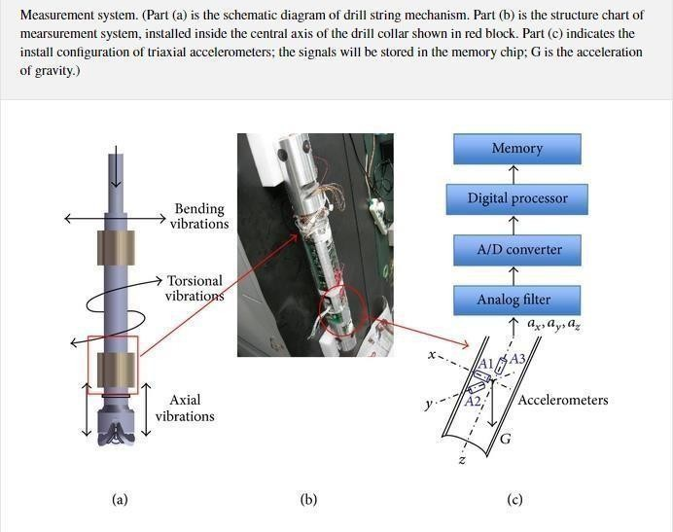

Figure: 14.2 Different measurement approaches

Baker Hughes
Baker Hughes bases their system on the root mean square (RMS) values from the instantaneous accelerations. Eight vibration severity levels are defined (numbered 0-7), for axial and transverse vibrations (table 4 and 5).

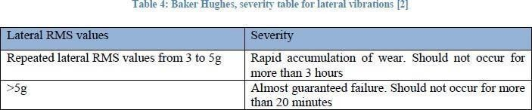
Table: 14.1 Baker Hughes severity for Lateral vibration

Table: 14.2 Baker Hughes severity for Axial vibration

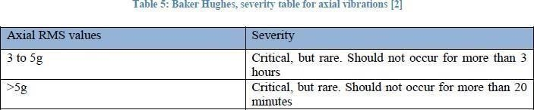

Halliburton

Halliburton separates the measured accelerations into three severity levels; low (green), medium (amber) and high (red). Both average and peak values are used to classify the severity of the vibrations. The average values are calculated over a period of 4 seconds and are both dependent on the size of the accelerations and the time span. The peak level is defined as the highest instantaneous acceleration in an interval of 4 seconds, and is categorized after size and frequency of occurrence.

Table: 14.3 Halliburton severity for Axial & Lateral vibration

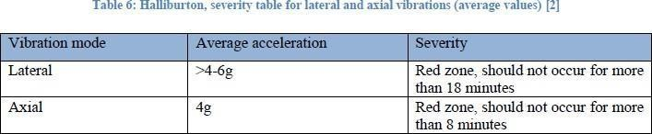

- BHA Design for Vibrations Optimization
BHA design has a significant effect on the severity of drill string vibrations. Significant improvement in performance has been seen by optimizing vibrations through the BHA design or in some cases BHA redesign. Good understanding of the effects of stabilizers and roller-reamers placement on bending forces and lateral stability enables development of optimized BHA design. There are several factors affecting the BHA design and optimization-

  - Weight on bit (WOB) and Torque on bit (TOB) should not exceed the threshold value.
  - WOB and TOB crosses the threshold limit top drive controllers ma fail.

  - BHA length should be large enough to avoid resonance and thus reduce drilling vibrations.
  - Use of BHA ant stall tools. These tools use springs and hydraulic oil to damp out the downhole vibrations. Major disadvantages of using these ant stall tools are that these are very expensive and subjected to damage under vibrations.
  - Adjustable stabilizers should be preferred, so that they can be relocated in order to reduce the vibration.

BHA Vibration Index
BHA performance is evaluated using vibration indices such as the BHA strain energy and stabilizer side force. Various tests have been conducted and from the results it can be concluded that BHAs with less strain energy and stabilizer side force show less mechanical specific energy (MSE), higher ROP, and less vibration. These indices are calculated under the steady state dynamics of a BHA.
Various models have been developed to evaluate the vibration indices e.g. Finite Element Method, Linear modelling process.
BHA indices values are calculated for different values of RPM. To obtain good dynamic performance over the whole operating range, the sum of squares of the index value at each RPM value is calculated as the cost function ‘J’.

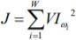

The cost function should be minimized. This function is minimized by optimizing the positions of stabilizers. The mechanism of this optimization is to modify BHA natural frequencies to avoid resonance. Contact points of the stabilizers acts as node so changing the position of stabilizers will change the frequency. When placing a stabilizer, a centralized location with minimal lateral displacement should be chosen, to minimize stress at the contact point.
We can also increase the natural frequency by increasing the BHA length but that may increase the load.

Stabilizer Placing
  - Stabilizers are very important component of BHA. The main purpose of stabilizers in any BHA is to stabilize and centralize the drill string while drilling.
  - Prevent whirl of the lower assembly, which will reduce bit movement and vibrations
  - Minimize bending and vibrations that cause tool joint wear
  - Prevent collar contact with the sidewall of the bore-hole
  - Minimize key-seating with differential pressure
  - Restrict lateral movement of the lower BHA as such they lower the strain on the drill collar and BHA connections
Stabilizer placement is a very important parameter for any BHA design. Proper spacing between stabilizers helps in reduction of shocks and vibrations and prevent BHA sagging. During MWD all the tools or measuring devices are placed on pre-defined places. After that stabilizers must be placed at optimum locations. When placing a stabilizer, a centralized location with minimal lateral displacement should be chosen, to minimize stress at the contact points. To reduce the vibration level, it is best practice to place a stabilizer near the bit. Adjustable stabilizers should be chosen so that their location can be changed to minimize vibrations, shocks and sagging.

Spacing between the stabilizers is an important considerable parameter for stabilizer placements in any BHA. To design any stabilizer placement programmed, following factors are always kept in mind-

- If the stabilizers are placed very far, they will cause lateral vibrations as the drill string is free to move. Along with vibrations it will cause BHA sagging, which will lead to incorrect measurement during MWD.
- If the distance will be more between stabilizers, number of stabilizers will be reduced. Lack of stabilization leads to whirling, mainly in pendulum assemblies.
- To reduce the vibration level, it is best practice to place a stabilizer near the bit.

- If we will decrease the spacing between stabilizers lateral vibrations and BHA sagging can be avoided to an extent.

- Minimize bending and vibrations that cause tool joint wear.
- As the number of stabilizers increases flexibility of BHA decreases. This may put constraints on directional controls.
- Increase in number of stabilizers increases the number of contact points. This will increase the torque and will cause torsional vibrations and stick-slip.

- Stabilizers have more diameter than the drill bit. When we provide weight to the bit, a fraction of it is transferred to stabilizers.

- So increase in number of stabilizers will require more weight to obtain the required weight on bit.

- When placing a stabilizer, a centralized location with minimal lateral displacement should be chosen, to minimize stress at the contact points.
- Any stabilizer that is placed near a non-magnetic surveying tool, must be made of non- magnetic material to prevent distortion of the survey results.

Some stabilizers can increase the risks of shocks and vibrations. For e.g. flex stabilizers. So if flex stabilizers are required for directional objective, should be placed closely and near the bit to increase the flexibility.

Edge Modification
Sharp edges on bottom hole tools such as drill bit, reamers and stabilizers have ability to cut and initiate pivot points at the borehole well, especially when the movement of the drill string is off- centre. This will generate the torque and affect the WOB and RPM measurement. Due to this movement cutting will be initiated in the direction of movement. Its severity is dependent upon the aggressiveness of the edge. If the bits are large with big moment arms this affect will be more intense. So edges of the tools should be modified to minimise the fluctuations in WOB RPM along with shocks and vibrations. By bevelling the edges on bit, stabilizers and underreamers shock and vibration can be minimized.
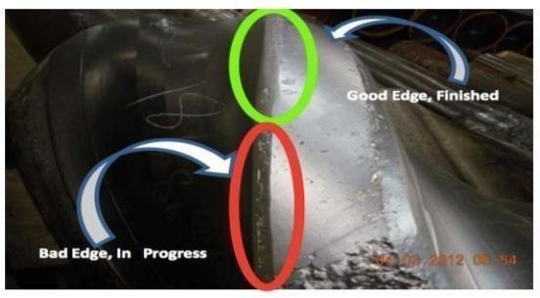

Figure: 15.1 Edge Modification

Roller reamers
Roller reamers are designed for reaming and stabilization in any type of formation. They help in reducing dogleg and patterns generated by whirl. All parts of the tools are made

of special alloy steel and heat treated for hardness. Roller reamers are also known as rotary reamers. Reamers are found of two types-

  - 3 point reamer
  - 6 point reamer

Drill string whirl leads to poor borehole conditions and may cause several problems such as hole enlargement which will result in random off center movement of drill string. This off center movement will cause lateral vibrations which are the most destructive form of vibrations and may damage a large part of bottom hole assembly. These lateral vibrations induce strong side forces in the stabilizers which increases the frictional drag at the contact points of the stabilizers. This frictional drag generate torque at the stabilizers which may result as stick-slip. When coupling takes place, a torsional vibration limit of the drilling system often prevents the driller from running sufficient WOB to prevent bit whirl, as this can drive the string into stick-slip.

Roller reamers are mostly used for hole conditioning but they are also able to decouple the stick-slip. So in such conditions stabilizers should be replaced by roller reamers. Roller reamers will decrease the contact area and thus friction drag with the help of low- friction bearing between BHA and the wellbore. So less torque will be generated. Now driller can increase the WOB which will lead to reduce bit whirl followed by increase in ROP.

Roller reamers don’t necessarily reduce the BHA whirl force but decrease the friction force and will prevent conversion of lateral force into torque. However bit whirl can be reduced by applying the additional torque. This decrease in bit whirl will reduce the whirl induced pattern, which will result in drilling a smoother and in-gauge hole. Since the hole is in-gauge stabilizers will have less room for lateral motion (caused by BHA whirl).

It may be possible that the BHA with conventional stabilizers may experience less vibrations than the BHA with roller reamers, but BHA with conventional stabilizers will experience stick-slip while BHA with roller reamers will show no such sign as the function of roller reamers is decoupling.

Anti-Stick-slip Technology (AST)
It can be difficult to predict bit-induced vibrations produced through rapid transitions in subsurface formations and equally hard to avoid them by preselecting bit and drilling parameters. AST is based on a dynamic, self-supported downhole mechanical system that actively controls the bit torque by manipulating the depth of cut.

The system automatically adjusts the drilling torque to counteract the torsional peak loads and stalls. The AST tool can be placed in the lower part of the BHA and thus makes it possible to quickly prevent the bit from stalling and thereby limit the risk of developing severe stick-slip vibrations. The mechanical function of AST is to convert the rise in the drilling torque that precedes a stall into an axial contraction, immediately cutting back the WOB. The reduction in WOB will reduce the DOC enough for the bit to keep on rotating. The conversion to axial contraction is s een as a reduction in the length of the helical spline. The spring and absorber is simultaneously compressed internally in the tool body above the telescopic unit. The absorbed energy in the spring is then fed back through the system to maintain steady torsional load.

The tool has also been utilized when torsional vibrations are generated by the drill string interaction with the borehole wall, compromising the quality of the real-time information from the MWD tools.

It is preferable to place the AST tool as close to bit as possible, often on top of logging BHAs, including stabilizers, to abate vibrations early on and supress stick-slip generated at the bit. However, the tool has been positioned both under and over the MWD and still maintained its functionality. In underreamer applications the tool should be placed above the reamer.
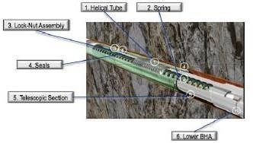

Figure: 15.2 Anti-Stick-slip Technology

Other tools for reduced vibration levels
It is important to mention that several other tools and procedures exist on the marked for vibration mitigation, some of these tools are mentioned below:

- V-stab, reduces the stick-slip tendencies and lateral shock by introducing forward synchronous whirl.
- Shock subs, absorbs vibrations and decreases the level of detrimental drill string vibrations.
- Mud motors, not primarily a vibration mitigation tool, but can serve to reduce stick- slip vibrations generated by the bit.

Anti-vibration tools should only be implemented in the BHA if the circumstances call for it. Each BHA must be adapted to the wellbore conditions and the specific operation at hand. If offset wells, formation hardness or other conditions indicates that the well will be troubled with detrimental vibrations, anti-vibration tools should be considered. In other operations the tools might be unprofitable.

With automations in the industry several better methods have been designed by several companies to mitigate vibrations. BHA modeling software has been developed, enabling drilling engineers to design vibration resistant BHAs. These models can be applied to configurations with the majority of common components, in all hole sections. For field use, BHA modeling can be utilized to predict optimum operating ranges for RPM and WOB and/or to compare the dynamic response of alternative BHA configurations.

INPUT Data from Baker Huges

Stiffness (N/m) | Mass (kg) | Max Torque (N·m) | Min Torque (N·m) | Lateral Force (N) | BHA Stiffness (N/m) | Rock Strength Coefficient (MPa) | Bit Diameter (m) | Well Depth (m) | Mud Pulse Velocity (m/s)
2061810.178 | 787.8338511 | 5125.716743 | 4724.797658 | 3568.126585 | 51777.95568 | 83.61772048 | 0.250627252 | 2309.371607 | 1533.144075
2926071.46 | 710.0531293 | 7545.641645 | 2718.685672 | 1336.55986 | 55403.90914 | 117.1948242 | 0.321297968 | 4707.65872 | 1467.521275
2597990.913 | 775.7995766 | 6257.423924 | 2434.684616 | 1646.514856 | 74045.46686 | 117.8444585 | 0.281738726 | 3515.757117 | 1427.266603
2397987.726 | 757.9309402 | 7034.282765 | 3468.358281 | 4594.216754 | 52676.88021 | 124.6200931 | 0.182586885 | 4479.372398 | 1571.906316
1734027.961 | 639.1599915 | 8630.265896 | 4956.951362 | 3425.716239 | 46779.70987 | 130.8263934 | 0.164113749 | 2960.148803 | 1333.359245
1733991.781 | 768.749694 | 5997.168917 | 2726.165815 | 1036.788206 | 62272.0505 | 148.3096456 | 0.278483856 | 4686.569685 | 1447.787531
1587125.418 | 435.3970008 | 6641.531692 | 4016.406642 | 1405.886171 | 77446.19097 | 116.1410244 | 0.155302262 | 3167.605036 | 1303.406093
2799264.219 | 478.393145 | 8022.204554 | 4284.858846 | 3654.007076 | 67841.19187 | 102.6069531 | 0.267155116 | 2032.512954 | 1440.598193
2401672.518 | 418.0909156 | 5915.192662 | 2712.912632 | 1020.246335 | 62802.4468 | 135.6630336 | 0.338046048 | 4716.145929 | 1316.890983
2562108.867 | 530.1321323 | 5307.919639 | 4184.649046 | 1643.232206 | 43887.05975 | 98.95825759 | 0.265094836 | 2273.86003 | 1335.645375
1530876.741 | 555.4709159 | 6159.005812 | 3103.349398 | 3194.935157 | 64600.28907 | 110.7279994 | 0.227633985 | 2957.940913 | 1335.257874
2954864.778 | 508.5396127 | 5644.885149 | 3896.917492 | 3767.580791 | 79602.154 | 85.49194669 | 0.278657644 | 4850.185901 | 1494.763091
2748663.961 | 731.4950037 | 8718.790609 | 3900.589132 | 3607.845038 | 45603.36061 | 81.77455204 | 0.241650578 | 4851.821441 | 1523.813464
1818508.666 | 542.7013307 | 8232.481518 | 3607.324052 | 1897.077238 | 60733.18609 | 147.385389 | 0.259123358 | 3720.313664 | 1475.01063
1772737.451 | 512.3738039 | 7533.615026 | 2270.86931 | 3848.716885 | 75094.92288 | 138.5186084 | 0.338292962 | 3895.511637 | 1588.651765
1775106.765 | 617.0784333 | 8485.842361 | 4505.907487 | 1948.99635 | 69630.74471 | 128.7181944 | 0.227220528 | 3345.336566 | 1412.461174
1956363.364 | 456.36969 | 8214.688308 | 2962.340195 | 2301.598793 | 67880.62964 | 108.6267061 | 0.342238113 | 2879.632315 | 1385.713626
2287134.647 | 720.8787923 | 5746.280236 | 2559.555531 | 3985.96562 | 68099.36336 | 92.1306024 | 0.331070128 | 2985.993636 | 1560.579738
2147917.528 | 429.8202575 | 8570.235994 | 2122.325425 | 3598.531596 | 54379.64605 | 90.95059299 | 0.189158227 | 4017.555368 | 1367.078752

Formulas Used

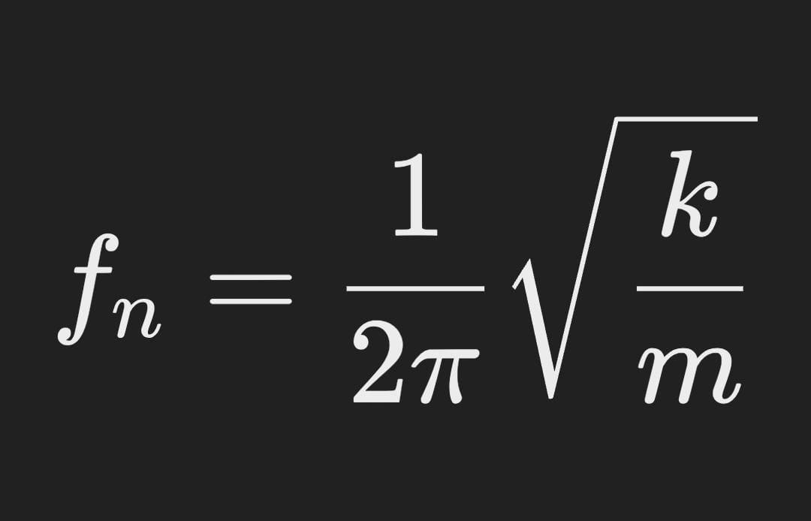 Drill string frequency

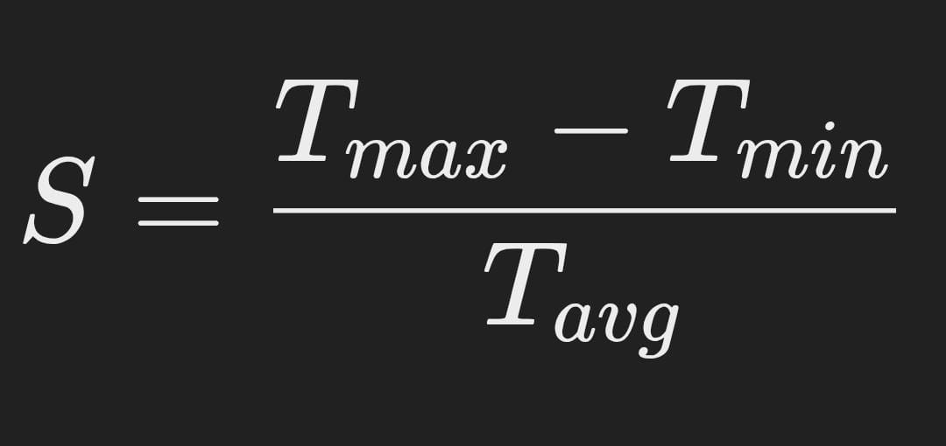 Stick-slip vibration severity index

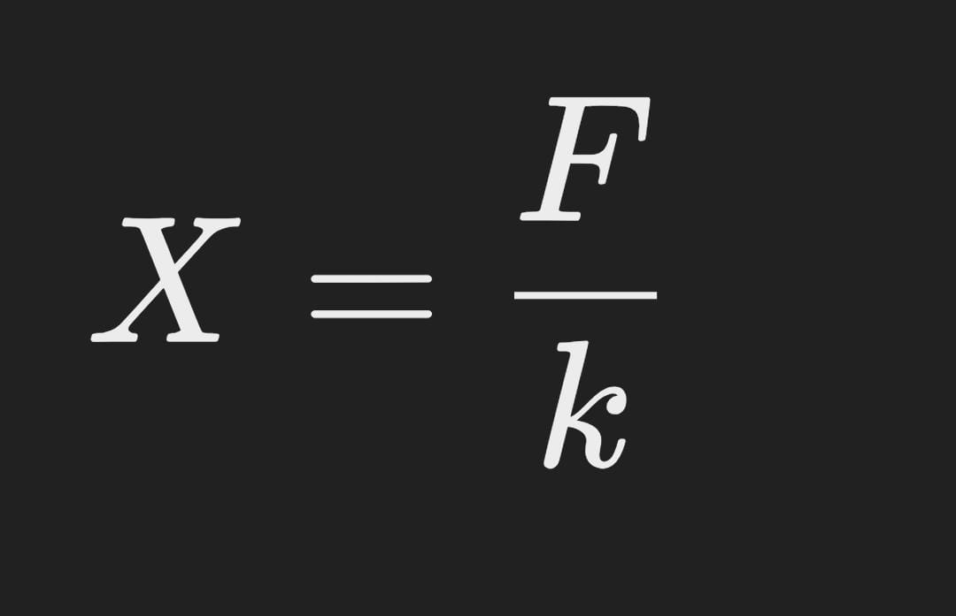 Lateral vibrational displacement
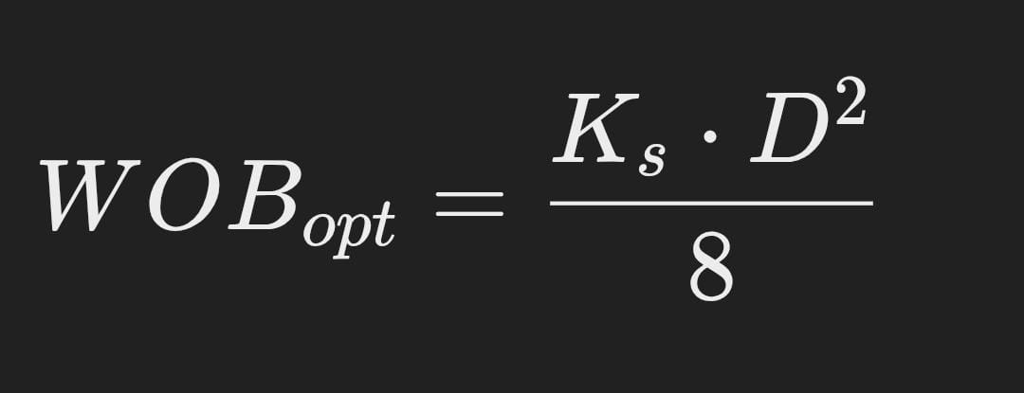 Optimal weight on bit

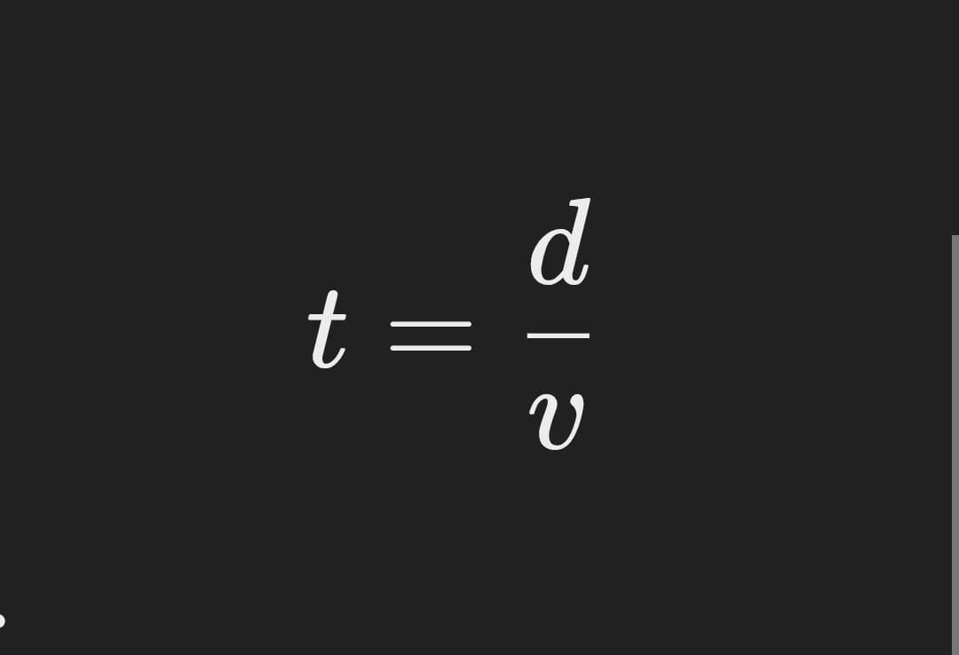 Mud pulse in signal transmission
OUTPUT DATA

Drill String Natural Frequency (Hz) | Stick-Slip Vibration Severity Index | Lateral Vibration Displacement (m) | Optimal Weight on Bit (N) | Mud Pulse Telemetry Signal Time (s)
8676.666792 | 1.647471701 | 0.036691802 | 776582.1375 | 2.611939388
5037.259883 | 0.975973783 | 0.041064027 | 333146.486 | 1.564338045
4729.906011 | 2.230278 | 0.021001876 | 1580579.239 | 2.329532133
4586.861279 | 1.233837238 | 0.044451432 | 1539104.793 | 2.745216335
5971.30992 | 1.690005756 | 0.068392923 | 1689602.132 | 2.879107969
12630.82802 | 1.460773109 | 0.099463553 | 713005.0228 | 2.95316752
7009.096188 | 0.975008222 | 0.055680572 | 1358717.314 | 1.58573615
5291.224754 | 2.745749747 | 0.015450118 | 1233692.864 | 2.375057943
3996.041827 | 1.230111622 | 0.016469574 | 1904809.837 | 2.531588261
4077.677858 | 1.017489843 | 0.091794638 | 246810.9349 | 2.979367607
11326.17975 | 1.284617208 | 0.025334824 | 477925.4361 | 2.365281423
8770.734351 | 2.576820349 | 0.067599146 | 1005371.923 | 2.63849575
4244.894289 | 0.964669491 | 0.03714231 | 1267075.816 | 1.722697765
4440.729169 | 1.462922505 | 0.026147808 | 1278511.063 | 2.939866814
4648.023122 | 1.103660495 | 0.051736718 | 2020681.537 | 2.850099447
8423.642332 | 1.222584662 | 0.033194497 | 538168.5177 | 2.014695935
12141.97073 | 1.385546545 | 0.062714017 | 1264738.923 | 3.049961723
4428.194707 | 1.52264956 | 0.019636268 | 876528.5251 | 2.024486837
5449.785607 | 1.703332473 | 0.096447703 | 389888.4516 | 1.563133757

Conclusion

Drill string vibrations are separated into three primary vibration modes. These vibration modes can be coupled to each other and thus makes it more challenging and complex to abate shock and vibrations. Lateral vibrations appear to be the most feared and destructive vibration motion, and this mode is strongly coupled to axial vibrations.

There are several tools and techniques that can be used to minimize shock and vibration to the BHA and thereby improve the overall drilling performance. The following mitigation actions are recommended:

  - The assembly must be sufficiently stabilized. The span length, effective placement, edge geometry, number and size of stabilizers should be analyzed in the BHA design optimization software.
  - Roller reamers should be used more frequently to decouple whirl and stick-slip in selected holes.
  - If bit-induced stick-slip is expected, e.g., in hard formations, AST can prove beneficial. The AST tool shows an ability to reduce the vibration level and at the same time improve the ROP. The technology requires critical evaluation and the associated risks and costs of the technology must be compared with the gain in overall performance.
Real-time downhole data monitoring is extremely important for early identification and prevention of drill string vibrations. Sensors are placed in the BHA/drill string to record downhole data and can be read at surface to adjust the drilling parameters and thereby minimize vibration and optimize the performance.

References
- Book - Tools and Techniques to Minimize Shock and Vibration to the Bottom Hole Assembly Larsen, L. (2014). Tools and techniques to minimize shock and vibration to the bottom hole assembly (Master's thesis, University of Stavanger, Norway).
- Xue, Q., Wang, R., Sun, F., & Huang, Z. (2014). Chaotic vibration analysis of the bottom rotating drill string. Shock and Vibration, 2014(1), 429164.https://www.linkedin.com/pulse/annular-pressure-while-drilling-djalu-suwondo/
- Rabia, H., & Brook, N. (1980, May). An empirical equation for drill performance prediction. In ARMA US Rock Mechanics/Geomechanics Symposium (pp. ARMA-80). ARMA...

- DANIEL, NWAMAIFE OLUCCHUKWU, and SE ADEWOLE. "SURVEY OF HORIZONTAL WELL SUCCESSES." (2023).
- Lake, L. W. (2007). Petroleum Engineering Handbook, Volume II Drilling Engineering. Society of Petroleum Engineering (SPE).
- Handbook of best Al-Yasiri, M., & Wen, D. (2019). Gr-Al2O3 Nanoparticles-based multifunctional drilling fluid. Industrial & Engineering Chemistry Research, 58(23), 10084-10091.
- Finger, J. T., & Blankenship, D. A. (2012). Handbook of best practices for geothermal drilling (No. SAND2011-6478). Sandia National Lab.(SNL-NM), Albuquerque, NM (United States
- Larsen, L. (2014). Tools and techniques to minimize shock and vibration to the bottom hole assembly (Master's thesis, University of Stavanger, Norway).
- Rodney, +P. F., & Wisler, M. M. (1986). Electromagnetic wave resistivity MWD tool. SPE Drilling Engineering, 1(05), 337-346
- Lu, C., Zhang, T., & Zhao, H. (2021). Improving the application depth of electromagnetic measurement while drilling (EM-MWD) systems by receiving signals from adjacent wells. Journal of Applied Geophysics, 195, 104468..
- Munaiseche, M., Saroinsong, T., Rumambi, H. D., Kondoj, M. A., Rangkang, J., & Kumaat, A. (2022). Similarity Check: Journal of Industrial and Business Management, 12(3). The Concept of Digital Entrepreneurial Ecosystem for SMEs in North Sulawesi, Indonesia. American
- MWD Electromagnetic Wave Transmission Method.Nov 27, 2018
- CRAIN, E., BLEUE, S., & INC, P. O. METALLIC MINERALS.
- Zinszner, B., & Pellerin, F. M. (2007). A geoscientist's guide to petrophysics. Editions Technip..
- Studer, R., & Macresy, L. (2006, September). Improved BHA Sag Correction and Uncertainty Evaluation Brings Value to Wellbore Placement. In SPE Annual Technical Conference and Exhibition.
- Regis, E., & Macresy, L. (2006). Improved BHA Sag Correction and Uncertainty Evaluation Brings Value to Wellbore Placement. In SPE Annual Technical Conference and Exhibition, San Antonio, Texas, USA, September. SPE-102088-MS. https://doi. org/10.2118/102088-MS.

- Florence, F. R., & Burks, J. (2012, May). New surface and down-hole sensors needed for oil and gas drilling. In 2012 IEEE International Instrumentation and Measurement Technology Conference Proceedings (pp. 670-675). IEEE.F.

- HEFFER, K. (2005). Institute of Petroleum Engineering, Heriot Watt University, Edinburgh EH14 4AS, UK. Understanding the Micro to Macro Behaviour of Rock-fluid Systems.
- MacBeth, S. P. C., & Shams, A. University Of Edinburgh, University of Newcastle, and Heriot Watt University, Institute of Petroleum Engineering.
- Nguyen, C. (2009). A study of underbalanced drilling application for granite basements in Vietnam (Doctoral dissertation, Heriot-Watt University).
- Mainal, M. (1986). Education for Offshore Engineering and Application to a Platform Design (Doctoral dissertation, ProQuest Dissertations & Theses,).
- Zarei, F. (2021). Optimal scheduling of field activities using constraint satisfaction problem theory (Doctoral dissertation, Heriot-Watt University)
- Chandra, V. (2015). Improving reservoir characterisation and simulation using near-wellbore upscaling (Doctoral dissertation, Heriot-Watt University)..
- Wang, F. (2010). Processing and analysis of transient pressure from permanent down-hole gauges (Doctoral dissertation, Heriot-Watt University).
- Alruwaili, K. M. M. (2016). Continuum and combined continuum-discontinuum analysis of wellbore mechanics and stimulation response (Doctoral dissertation, Heriot-Watt University).

CHAPTER – II
LITERATURE REVIEW
Authors:. Larsen, Lena
Journal: (Master's thesis, University of Stavanger, Norway).
Title: Drill string vibration is a widely studied topic
Drill string vibration is a widely studied topic. This paper developed a real-time measurement system near the drilling bit and extracted the lateral vibration, longitudinal vibration time series of bottom rotating drill string. In order to reconstruct the phase space, we estimated the delay time with mutual information and calculated the embedding dimension through Cao’s method. Finally, the chaotic characterization of the system is analyzed by calculating the correlation dimension and the largest Lyapunov exponent. The results show that such system can exhibit positive finite-time Lyapunov exponents and a clear convergence toward the correlation dimension, which is a strong indicator for the chaotic behavior of the system. It is expected that the new dynamics found in this paper could be of potential implication to the control methods of the drill string vibration.
The results of research into the impact strength of rock using a “Protodyakonov” type drop hammer apparatus are reported. The size of the original apparatus and the volume of charge required are critically discussed and modified to allow the testing of small fragments of size 4-8 mm. The new modified versi on of the apparatus, referred to as the “Small Drop Hammer”, is then used to determine the ROCK IMPACT HARDNESS NUMBER (RIHN) of crushed rock particles and drill cuttings. The drill cuttings results are shown to be erratic and, therefore, can not be used for accurate prediction of drill performance.
Authors: Rolla, Missouri.
Journal: Chaotic vibration analysis of the bottom rotating drill string.
Title: An Empirical Equation For Drill Performance Prediction .
The average field drilling rate of a rock is related to the power input in terms of operating pressure, the RIHN and the shore hardness of fresh pieces of the rock collected from the quarry face. An empirical equation is proposed and shown to be adequate for predicting drilling rates for both down-the-hole and drifter drills.
The ability to predict the performance of rock drills is important in drilling operations. Contractors could use prediction equations to estimate the total drilling costs of a venture, and the drilling machine best suited for a particular rock type and working conditions could be then selected. The manufacturer could use prediction equations to check improvements in the design of existing drills.
In the past, the compressive strength of a rock was used to predict the drilling rates of a particular rock. Experience, however, has shown that some rocks with high values of compressive strength can be drilled at faster rates than the compressive strength value indicates. Laboratory developed “Drillability Equations” give gross errors when used to evaluate the field machine performance (1,2). This is because such equations are determined under conditions that are entirely different from field situations.
Field drilling coupled with the collection of drill cuttings has received cursory attention in the literature. This paper examines the use of drill cuttings results to evaluate the possibility of arriving at an index of drillability.
The average drilling rate at a particular operating pressure of a number of drill holes is related to the physical properties most pertinent to the percussive drilling mechanism, by an empirical equation.
Authors: NWAMAIFE OLUCHUKWU DANIEL.
Journal: SE ADEWOLE. "SURVEY OF HORIZONTAL WELL SUCCESSES." (2023).
Title: SURVEY OF HORIZONTAL WELL SUCCESSES

Horizontal drilling has become a key technology used to reduce costs and enhance recoveries from producing reservoirs. Through 2001, commercial databases contained records on 34,777 horizontal wells from 72 countries. Canada (18,005wells) and the United States (11,344 wells) were the leading countries for horizontal drilling. More than 5400 horizontal wells were recorded outside of North America. Russia, Venezuela, Oman, United Arab Emirates, Nigeria, Saudi Arabia, and Indonesia were the leading countries in terms of numbers of wells. Wells drilled by major operators (Bp, Cheveron, Conphil, Eni, Shell and Total) and independent operators (Anadarke, Apache, Hess, Maersk, Marathon, Murphy, Noble, Oxy, Repsol, Talisma) where discussed in this research. Wells drilled in Hassi R’Mel Oil Rim , Algeria used in oil reservoir recovery were discussed.
Authors:James
Journal: . In ARMA US Rock Mechanics/Geomechanics Symposium
Title: The Petroleum Engineering Handbook
The Petroleum Engineering Handbook, Volume II: Drilling Engineering is a comprehensive reference book published by the Society of Petroleum Engineers (SPE). It is part of a multi-volume series that provides in-depth information about various aspects of petroleum engineering. Volume II, specifically focused on drilling engineering, covers a wide range of topics related to the drilling process in the oil and gas industry.
Authors: Guoshuai Wang,
Journal: ACS Applied Nano Materials 2021
Title: Gr-Al₂O₃ Nanoparticles-Based Multifunctional Drilling Fluid
Various chemical additives are used in drilling fluids to improve drilling efficiency and increase oil production. Dispersing nanoparticles as additives in drilling mud is one of the more promising techniques that could help solve many difficulties of drilling operations. However, the existing research in this field is insufficient and suffers from numerous inconsistent outcomes. This study aims to discover and evaluate the impact of graphite-alumina hybrid nanoparticles on the rheology, thermal properties, zeta potential, and electrical conductivity of water-based drilling fluids. This study shows that that the addition of nanoparticles improves the effectiveness of water-based mud (WBM), both in static and dynamic situations due to the establishment of an appropriate gel structure that can be easily broken under low shear stress. Furthermore, these nanoparticles improve the degree and the speed of structural recovery by reducing the relaxation time, which is necessary to avoid the sedimentation of weighting materials and drilled cuttings. Besides, nanoparticle seeded fluid improves the effective thermal conductivity of conventional drilling fluids, and the highly charged suspension resulting from the addition of nanoparticles is desirable for drilling operations. It is also observed that nanoparticles could penetrate through the porous wall of the wellbore and clog the pores, forming a thin and impermeable cake that reduces drilling fluid loss

Authors Sandia.
Journal: . Society of Petroleum Engineering (SPE).
Title: Handbook of Best Practices for Geothermal Drilling
.
This Handbook is a description of the complex process that comprises drilling a geothermal well. The focus of the detailed Chapters covering various aspects of the process (casing design, cementing, logging and instrumentation, etc) is on techniques and hardware that have proven successful in geothermal reservoirs around the world. The Handbook will eventually be linked to the GIA web site, with the hope and expectation that it can be continually updated as new methods are demonstrated or proven.
Authors: Larsen, L.
Journal: multifunctional drilling fluid. Industrial & Engineering Chemistry Research.
Title: Tools and techniques to minimize shock and vibration to the bottom hole assembly.
When drilling a well there is a risk of serious damage caused by drillstring vibrations. Shock and vibration are identified as a cause of premature failure on drill bit and components in the bottom hole assembly (BHA), resulting in lost time for operators and costing service companies several millions in repair each year. The expenditures incurred by drillstring vibrations include reduced rate of penetration (ROP), tripping and poor drilling performance. Currently, several tools and techniques are used in the attempt to minimize shock and vibration. For vibration mitigation to be more effective in the future, the most effective tools and techniques must be designated, implemented and improved. The main objectives of this thesis are to give an insight into the main vibration problem and determine effective mitigation tools and techniques, with regards to the BHA design, which can minimize shock and vibration, and improve the drilling performance in the future. A particular focus was given to anti-vibration tools, and vibration prevention in underreamer applications. The thesis is divided into four main parts; theory on drillstring vibrations, evaluation of various tools and techniques for vibration mitigation, including supplier input, a performance analysis of the Anti Stick-slip Technology (AST) and finally a discussion and conclusion part. Several field case studies are presented to illustrate how the tools and techniques can reduce the risk of detrimental vibrations. The work is based on literature reviews and is substantiated by comparative field experiences. Additional information was acquired through conversations with Statoil, the directional drilling suppliers and tool suppliers. These conversations proved highly valuable and resulted in several proposed tools and techniques that should be considered when designing the BHA. The thesis revealed that BHA design awareness can lead to huge advancements in terms of minimizing shock and vibration. Roller reamers should be added to the assembly if high stick-slip levels are expected or if the stabilizers experience extensive friction. Anti-vibration tools, such as AST and Frank´s Harmonic Isolation (HI) tool should be considered, as field experience indicates that these tools can reduce the vibration level.
Authors: F.RODNEY
Journal: Sandia National Lab.(SNL-NM), Albuquerque, NM (United States)
Title: measurement-while-drilling (MWD) resistivity logging tool.
This paper is an overview of the development of a 2-MHz [2×10⁶-cycle/sec] measurement-while-drilling (MWD) resistivity logging tool. This tool uses propagating electromagnetic waves rather than the pseudostatic fields of its low-frequency counterparts. The basic theory of operation is presented along with a discussion of the factors that affect tool response and the compromises that led to the specific embodiment. Field data are presented from which a comparison is made between this tool and wireline tools. It is seen that it is often possible to obtain a direct reading of true formation resistivity, Rt, with this tool.
Authors: Huibin Zhao
Journal: (Master's thesis, University of Stavanger, Norway).
Title: mproving the application depth of electromagnetic measurement while drilling (EM-MWD) systems by receiving signals from adjacent wells

EM-MWD systems transmi ia an information channel composed of drill string and formation, and the formation has a strong attenuation effect on the signal. in EM wave transmission in the formation limits the application well depth. This paper discusses several commonly used methods to improve the depth of EM-MWD applications, including turbine power supplies, adaptive ,. transmitting antenna extensions, and repeater. . Based on both theory and practice, the characteristics of these methods are analyzed. An EM-MWD system in which signals are received from an adjacent well is proposed, and a formula for calculating the receiving voltage for an adjacent well is derived based on a model of this system. According to this formula, the proposed EM-MWD system can greatly increase the receiving voltage, where deeper adjacent wells provide a greater increase in the receiving voltage and a greater maximum transmission depth for the EM-MWD system. In-hole experiments of this EM-MWD system based on signals received from an adjacent well demonstrate that this method can effectively increase the voltage of the received signals on the ground, in agreement with theoretical results.
Authors: SANDRA BLEUE.
Journal: SPE Drilling Engineering
Title:Borehole logging in the mining environment.
The examples shown in this article illustrate the possibilities for the integration of diverse data sets that can reduce the risk of misinterpretation and help to meet the objectives of an eco-friendlier industry. The multiple and overlapping usages of surface exploration methods provide real solutions to real exploration issues. The “petro” in Petrophysics means “rock”, not “petroleum”! The right kind of rock is what mining engineers, management, and shareholders are looking for. It is time to integrate all our petrophysical / geoscience skills to find those deeper prospects we know must be out there. Our world depends on our success.
Authors:Antony.A
Journal: (EM-MWD) systems by receiving signals from adjacent wells. Journal of Applied Geophysics
Title: A geoscientist's guide to petrophysics
For this article, we are expanding the definition of petrophysics to include the exploration methods performed on or near the surface to locate potential ore bodies, using all the physical principles from oilfield well logging experiences. The next article, the last in our Green Economy Series, covers borehole logging in the mining environment.
Authors: , San Antonio.
Journal: The Concept of Digital Entrepreneurial Ecosystem for SMEs in North Sulawesi, Indoesia
Title: Improved BHA Sag Correction and Uncertainty Evaluation Brings Value to Wellbore Placement.
Recent well positioning uncertainties evaluation per SPE published ISCWSA model for MWD survey tools suggests that 80% of the inclination measurement error budget is a consequence of BHA sag.
BHA sag is the misalignment of the directional sensor with the borehole direction due to deflection of the MWD drill collar under gravity and borehole curvature. The magnitude of the error depends on BHA type and geometry, sensor spacing, hole size and several other factors.
This paper presents a new methodology based on modern 3D BHA/Hole interacting modeling for BHA sag corrections and residual error evaluation at each MWD survey stations.
11 different typical 17½" and 12¼" rotary and steerable motor BHA's with variable gauge stabilizers were computed in multiple configurations (borehole geometry, BHA settings, friction…) following a Monte Carlo process which involved more than a million simulations. Results of this study show that the residual BHA sag uncertainty as proposed by the ISCWSA model can be further reduced by as much as 50%.
A simplified software automated process was developed in order that Operations Support Centres can easily integrate the proposed methodology as part of near real time Survey Management advanced processing routines.
A sound BHA sag correction method along with a thoroughly analysed residual sag error, readily fit for use within the ISCWSA MWD well positioning uncertainty model (today's industry standard), appears essential in a wide variety of directional drilling applications including extended reach and horizontal drilling.
Authors: L Macresy
Journal: MWD Electromagnetic Wave Transmission Method.
Title: Improved BHA Sag Correction and Uncertainty Evaluation Brings Value to Wellbore Placement.
Recent well positioning uncertainties evaluation per SPE published ISCWSA model for
MWD survey tools suggests that 80% of the inclination measurement error budget is a
consequence of BHA sag. BHA sag is the misalignment of the directional sensor with the
borehole direction due to deflection of the MWD drill collar under gravity and borehole
curvature. The magnitude of the error depends on BHA type and geometry, sensor spacing,
hole size and several other factors. This paper presents a new methodology based on the MWD.
Authors: FR Florence
Journal: CRAIN, E., BLEUE, S., & INC, P. O. METALLIC MINERALS.
Title: New surface and down-hole sensors needed for oil and gas drilling.
The history of oilwell drilling includes a number of innovative techniques to infer the conditions down-hole and their impact on drilling performance. Surface and down-hole sensors have been deployed to measure related physical phenomena that can be generally associated with the actual environment. Some direct measurements have been made after drilling using sensors suspended on a wire line, and this evolved into near real-time measurements using Measurement While Drilling (MWD) and Logging While Drilling (LWD) equipment that use low bandwidth pulse telemetry communications. With the advent to high speed wired drillpipe, new sensors are needed to take advantage of the improved telemetry capabilities to produce true real-time measurements. New surface sensors are needed that employ smart technologies and enhanced data processing. By combining these high-speed, high quality measurements with predictive models, set points and limits can be directly connected to the latest generation of open-architecture rig control systems to improve drilling safety and efficiency. This paper briefly outlines the shortcomings of a wide variety of existing sensor designs and identifies emerging technologies that could provide better measurements if the harsh environmental constraints can be met. The authors then call to non-industry participants to adapt sensor technologies used in other commercial applications to help automate the process of drilling for oil and gas. They discuss where the oil and gas industry needs accurate, real-time measurements of chemical, rheological and physical properties, and how these measurements could be used. They also address the need for power generation and/or storage to overcome challenges encountered today. The paper ends with a look ahead as the industry seeks new sensors, perhaps based upon a very different set of physical measurements that will improve our ability to safely produce oil and gas until alternate energy sources become commonplace.
Authors: Kes J Heffer, Richard J Fox, Colin A McGill, Nick C Koutsabeloulis
Journal: A geoscientist's guide to petrophysics. Editions Technip..
Title: Fault structure and geomechanical changes in mature waterfloods.
Recent studies have revealed a strong correlation between the directionality of reservoir flow in waterfloods and the local orientation of horizontal earth stresses. Field applications are described of a novel technique of determining interaction between wells as a potential indicator of flow directionality. This technique calculates the Spearman rank correlation coefficient between flow rates at pairs of wells. These applications have demonstrated that the reservoir dynamics associated with correlated rate fluctuations have at least some component coupled to geomechanics. Coupled geomechanical-fluid flow numerical modelling is able to explain some of the observations and offers an improved predictive tool for planning and managing waterfloods and determining optimal locations for infill wells.
Authors:Jhon davit
Journal: In SPE Annual Technical Conference and Exhibition.
Title: FILTRATION PROPERTIES OF WATER BASED DRILLING FLUIDS
This thesis reports an experimental and theoretical study on filtration properties of water based drilling fluids under dynamic and static conditions. The tested muds cover Freshwater/Gypsum/Lignosulphonate mud and SeawaterlKCLlPolymer mud, barite weighted and unweighted. The effects of the solid concentration, pressure and shear rate on the filter cake characteristics and the erodability were investigated. For static filtration experiments, all tests were conducted for two hours and the spurt loss, the filter cake thickness, the ratio of wet to dry cake mass and the cumulative filtrate volume against time were measured. For dynamic filtration experiments, however, only the spurt loss and the cumulative filtrate volume against time were measured and all tests were conducted for at least 8 hours. A general filtration equation was developed based on the cake filtration theory prevailing in the chemical engineering industry and it was utilised to obtain the modified classic static filtration equation and the dynamic filtration equation. The modified classic static filtration equation was then employed to fit the static filtration experimental data and the average specific static cake resistance and the effective filter medium resistance were calculated. The dynamic filtration equation showed a substantial agreement with the dynamic filtration experimental data. Using the static filter cake properties such as the ratio of wet to dry cake mass (m), the average specific dynamic cake resistance, the effective filter medium resistance and the dynamic filter cake erodability were calculated. In the study of the relationship between the static filtration data and the dynamic filtration data, an attempt of predicting the dynamic filtration data from the static filtration experimental data was conducted. Also, an attempt was carried out to predict the static filtration data and the dynamic filtration data in a sequential process.
Authors: Nguyen, Cuong
Journal: In SPE Annual Technical Conference and Exhibition, San Antonio, Texas, USA, September.
Title: A study of underbalanced drilling application for granite basements in Vietnam.
Underbalanced drilling (UBD) has gained popularity during the recent years as it provides a method to prevent formation damage, minimize lost circulation risks, and increase the rate of penetration. However, drilling with a bottomhole pressure less than the formation pore pressure will often increase the risk of borehole instability due to the shear or compression failure of the rock adjacent to the wellbore. The extent of rock failure is related directly to the pressure in the annulus between the drillpipe, collars and the wellbore which can only be calculated through modelling multiphase flow in the drilling system. The relationship between rock failure and wellbore hydraulics becomes more complex due to the appearance of the influx formation fluid in UBD. Therefore, the aim of this research is to describe methods to solve the complex interaction of wellbore stability, rock yielding, collapse, wellbore hydraulics, and production capacity during UBD operations. To achieve the aim, analytical and numerical solutions have been codified into two programs WELLST, and UBDRILL. Commercial software packages such as ABAQUS, PERFORM, HYMOD were also used to model the process. Field data from granite basement reservoirs of Basin X, Vietnam were used as the parameters input into the model to calculate. This research includes: • An analysis of the influences of time dependence, thermal and hydraulic diffusivity, wellbore pressure changes, inclination and azimuth variation, poroelastic and thermo-poroelastic deformation, cooling and heating effects on wellbore stability in UBD. • An analysis of pressure, temperature, fluid properties distribution in the annulus and inside the drillpipe while UBD. • An analysis of the suggested liquid gas rate window (LGRW) which gives field engineers flexibility in the selection of liquid and gas injection rates on the drilling site when UBD is applied. • An estimation of production capacity in UBD operations. These results were obtained by analyzing the field data of granite basement formations and clastic formations of Basin X, Vietnam which is under compression in a strike-slip environment.
Authors: Mohd. Ramzan.
Journal: In 2012 IEEE International Instrumentation and Measurement Technology Conference Proceedings (pp. 670-675). IEEE.F.
Title: Education for Offshore Engineering and Application to a Platform Design.
This thesis considers some of the patterns and requirements of education available in the United Kingdom for offshore engineering at the level of first degree and postgraduate courses. These requirements are illustrated by a design study for an offshore oil platform and associated steel jacket for waters east of West Malaysia in the South China Sea. Proposals are then made for courses in offshore engineering suitable for Malaysia. The first part of the thesis traces the rise of the offshore industry which is mainly the offshore oil industry and the growth of tertiary education for this industry. It draws attention to the breadth of interests required and the absence of undergraduate courses which treat offshore engineering as a totally distinct branch of engineering under the accreditation procedure of a professional engineering institution. Demand is met by courses which represent sub-specialisation for students who begin in other branch of engineering. A similar pattern exist in the postgraduate education which if anything draws from a wider background. Design of an offshore oil production platform illustrates the breadth of education required although the thesis limits numerical consideration to the design of steel lattice jacket under operational and environmental loadings. The relatively shallow water off the Malaysian coast is less severe compared to the North Sea. The oil industry requires manpower at all levels of expertise and the last part of the thesis considers a pattern for this education for technicians, professional and postgraduate engineers
Authors: Zarei, Faraj
Journal: Edinburgh EH14 4AS, UK. Understanding the Micro to Macro Behaviour of Rock-fluid Systems.
Title: Optimal scheduling of field activities using constraint satisfaction problem theory
The challenge of identifying problematic wells and planning their workover operations is common in oil and gas fields. On top of this, the well intervention resources are seldom easily accessible so it is crucial to target the right set of wells at the right time. Oil and gas reservoirs are complex dynamic systems the production and injection patterns of which can significantly affect the reservoir and well response. This represents a complex mathematical optimisation problem where the overall life performance of the field strongly depends on the workover planning decisions. This work presents a reliable and effective tool that is able to screen and explore the large search space of the potential work-overs that adds value to the reservoir management process. The proposed solution considers the overall performance of the field throughout a specified period while respecting all operational limitations as well as considering the risks and costs of the interventions. The proposed workflow combines the commercial optimiser techniques with constraint satisfaction problem optimiser to identify the optimal workover scheduling. The schedule found is guaranteed to satisfy all predefined field constraints. The presented results showed better performance achieved by the proposed hybrid Algorithm in maximising the defined objective function. The suggested workflow can greatly enhance the decisions related to field development and asset management involved with large number of wells and with limited intervention resource.
Authors: VISWASANTHI CHANDRA
Journal: Institute of Petroleum Engineering
Title: IMPROVING RESERVOIR CHARACTERISATION AND SIMULATION USING NEAR-WELLBORE UPSCALING.
The copyright in this thesis is owned by the author. Any quotation from the thesis or use of any of the information contained in it must acknowledge this thesis as the source of the quotation In this thesis, novel workflows involving high resolution near-wellbore modelling (NWM) are illustrated, which allow integration of multi-scale geological and petrophysical data from highly heterogeneous reservoirs in field-scale reservoir simulations. When applied to a clastic reservoir with high variance at small scale, NWM significantly improved reservoir characterisation and calibration of reservoir model with well test data. Results show that using NWM tools for reservoir modelling yields more precise flow calculations and improves our fundamental understanding of the interactions between the reservoir and the wellbore. Furthermore, this thesis employs an integrated NWM workflow to identify and evaluate the geological heterogeneities that enhanced reservoir permeability in a giant carbonate reservoir with a long production history. Key among these heterogeneities are mechanically weak zones of solution-enhanced porosity, leached stylolites and associated tension gashes, which were developed during late stage diagenetic corrosion. The results of this investigation confirmed the critical role of diagenetic corrosion in enhancing the permeability of the reservoir. One of the key aims of this thesis is to develop a novel near-wellbore upscaling (NWU) workflow that addresses the challenges associated with conventional carbonate modelling workflows. The NWU workflow developed in this thesis provides a systematic geostatistical approach to obtain more realistic representation of the above multi-scale geological-petrophysical heterogeneities in the reservoir simulation model of the carbonate field. The NWU results were used to generate global porosity-permeability and vertical-horizontal permeability relationships for reservoir simulation. Instead of applying artificial permeability multipliers that do not necessarily capture the impacts of geological heterogeneities, the NWU workflow incorporates representations of fine-scale heterogeneities in the reservoir simulation model.Another aim of this thesis is to develop a new near-wellbore rock-typing and upscaling approach to improve the integration of reservoir rock-typing and simulation in carbonate reservoirs. The rock-typing and upscaling methodology described in this work involves the geological-petrophysical classification of the reservoir heterogeneities through systematic evaluation of the key diagenetic events, including the key associations between the depositional and diagenetic features, and their impact

ivon reservoir flow properties. The near-wellbore rock-typing and upscaling workflow yielded consistent initialisation of the reservoir simulation model and therefore improved the calculation of volumes of fluids-in-place. Subsequently, the cumulative production curves computed by the reservoir simulation model agreed well with the historic production data. The revised simulation model is now much better constrained to the reservoir geology and provides an improved geological-prior for history matching.

Authors: Wang, Fei.
Journal: (Doctoral dissertation, Heriot-Watt University).
Title: Processing and analysis of transient pressure from permanent down-hole gauges
With the permanent down-hole gauge (PDG) widely installed in oilfields around the world in recent years, a continuous stream of transient pressure data in real time are available, which motivates a new round of research interests in further developing pressure transient analysis techniques. PDG data is recorded under the unconstrained circumstances, so that it cannot avoid effects due to noise, rate fluctuation and interference from other wells. These effects make the measured pressure trends declining or rising and then obscure or distort the traditional flow behavior, which makes the following analysis difficult. In this thesis, the problems encountered in analysis of PDG transient pressure are investigated. A new algorithm, multi-well deconvolution, and corresponding computer codes are developed. The algorithm is based on linear recursion with added non-linear least squares optimization to deal with the noise problem in time domain. With this developed algorithm, the inter-well interference effect can be extracted and the variable-rate superposition effect can be solved at the same time. New deconvolution-based rate transient analysis and pressure transient analysis methods are both proposed in this thesis. Numerical well testing synthetic studies are performed to demonstrate these procedures. The results prove that the new method works well in homogeneous reservoirs with two wells flowing at single phase, multiple rates.

Authors: Khalid Mohammed M Alruwaili
Journal: Education for Offshore Engineering and Application to a Platform Design .
Title: Continuum and Combined Continuum-Discontinuum Analysis of Wellbore Mechanics and Stimulation Response.

Wellbore drilling and stimulation activities are interlinked processes within the task of borehole construction. Before drilling a well, the initial stress state in the rock can be defined by three principal stresses, with a typical assumption that these consist of the vertical stress (σv), the maximum horizontal stress (σH) and the minimum horizontal stress (σh). After drilling, the stress state changes around the created borehole. The fundamental engineering problem then is to calculate the stresses around the created borehole and/or at the borehole’s wall. Numerous analytical and numerical models exist to estimate the stresses around a circular hole, but these models cannot explain the observed phenomena either in the field or the lab. Attention here is focused on models that are commonly used to predict the stress state around a circular opening. These models do not account for the sequence of the physical processes, leading to an inadequate stress state estimation. This research investigates the 2D classical analytical method, along with a comparison of that approach against numerical methods. This investigation reveals that the models are not equivalent. This is not because of mathematical issues, but is due to the fact that the mechanical systems expressed by these models are not equivalent. The drilling model captures the physics of the real process which makes it possible to explain some phenomena observed in field and laboratory tests. The drilling model approach is applied for several sedimentary rock examples. The combined continuum-discontinuum method reveals its capability in calculating rock failure and deformation that is comparable to some published laboratory drilling tests. Also, the simulation results shed light into the complex fracture growth regime around the wellbore. Drilling and Hydraulic fracture simulation is carried out for Berea sandstone using both the continuum and the combined continuum discontinuum methods. The results are in good agreement which identifies a practical engineering method for larger models. The fracturing initiates in Mode II (shear) near the circumference of the wellbore aligned with the maximum stress. At later stages, Mode I (tensile) fractures also develop and propagate the fracture parallel to the maximum horizontal stress. This fracturing mechanism continues for as long as the pressure is applied.

